ELIZABETH R
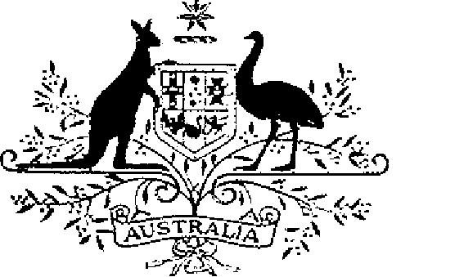

ELIZABETH THE SECOND, by the Grace of God Queen of Australia and Her other Realms and Territories, Head of the Commonwealth:
TO ALL to whom these Presents shall come,
GREETING:
WHEREAS it is desirable that there be instituted an Australian medal for the purpose of according recognition to persons who render outstanding public service:
KNOW YOU that We do by these Presents institute a medal to be designated and styled the Public Service Medal:
AND WE DO ordain that the award of the medal so instituted shall be governed by the Regulations Governing the Award of the Public Service Medal set out in the Schedule.
IN WITNESS whereof We have caused these Our Letters to be made Patent.
GIVEN under the Great Seal
of Australia at Our Court at St James’s on 18 October 1989
L.S..
By Her Majesty’s Command,
BOB HAWKE
Prime Minister

Schedule
Regulations Governing the Award of the Public Service Medal
Short title
1. These Regulations may be cited as the Public Service Medal Regulations.
Interpretation
2. In these Regulations:
“authority” includes:
(a) a body corporate in which the Commonwealth, a State or a local government has a direct or indirect pecuniary interest; or
(b) an unincorporated body established by or for the Commonwealth, a State or a local government;
“local government” means a local government body established under a law of a State;
“Medal” means the Public Service Medal;
“service” means remunerated service;
“State” includes the Northern Territory and the Territory of Norfolk Island.
Conditions for award of the Medal
3. (1) The Medal shall be awarded to a person only for outstanding public service by the person:
(a) with the Commonwealth, a State or a local government or with an authority of the Commonwealth, a State or a local government; or
(b) in an office or position remunerated by or on behalf of the Commonwealth, a State or a local government.
(2) The Medal shall not be awarded to a person in respect of:
(a) service with the Commonwealth or with an authority of the Commonwealth; or
(b) service in an office or position remunerated by or on behalf of the Commonwealth;
if that award would result in the number of awards made in respect of that type of service during a calendar year exceeding 33.
(3) The Medal shall not be awarded to a person in respect of:
(a) service with a State specified in the following table, or with an authority of that State;
(b) service with a local government of that State or an authority of that local government; or
(c) service in an office or position remunerated by or on behalf of that State or that local government;
if that award would result in the number of awards made in respect of that type of service during a calendar year exceeding the number set out opposite the name of that State in the following table:

New South Wales | 22
Victoria | 17
Queensland | 11
Western Australia | 6
South Australia | 6
Tasmania | 3
Northern Territory | 2

(4) The Medal shall not be awarded to a person in respect of:
(a) service with the Territory of Norfolk Island or with an authority of that Territory; or
(b) service in an office or position remunerated by or on behalf of that Territory;
if that award would result in the number of awards made in respect of that type of service during a period of 3 calendar years exceeding one.
Making of awards
4. (1) An award of the Medal shall be made by the Governor-General and notified in the Commonwealth of Australia Gazette.
(2) The Medal shall not be awarded except upon the nomination of the responsible Minister.
(3) For the purposes of subregulation (2), the responsible Minister is:
(a) in the case of service with the Commonwealth, with an authority of the Commonwealth or in an office or position remunerated by or on behalf of the Commonwealth—the Prime Minister or a Minister of State for the Commonwealth acting for and on behalf of the Prime Minister;
(b) in the case of service with a State, a local government of the State, an authority of the State or of the local government or in an office or position remunerated by or on behalf of the State or the local government—the Premier of that State or a Minister of the Crown of that State acting for and on behalf of the Premier;
(c) in the case of service with the Northern Territory, a local government of the Territory, an authority of the Territory or of the local government or in an office or position remunerated by or on behalf of the Territory or the local government—the Chief Minister of that Territory or a Minister of that Territory acting for and on behalf of the Chief Minister; or
(d) in the case of service with the Territory of Norfolk Island, an authority of the Territory or in an office or position remunerated by or on behalf of the Territory—the Minister of State for the Commonwealth responsible for the administration of that Territory on the advice furnished by the executive member of the Legislative Assembly of that Territory responsible for public service matters or an executive member acting for and on behalf of that member.
Design of the Medal
5. The design of the Medal shall be as prescribed.
Wearing of the Medal
6. The manner of wearing the Medal shall be as determined by the Governor-General.
Designation of holder of the Medal
7. Persons to whom the Medal has been awarded are entitled to have the letters “PSM” placed after their names on all occasions when the use of such letters is customary.
Registrar of Awards
8. (1) There shall be a Registrar of Awards who shall be appointed by the Governor-General and shall maintain a Register of the names of persons to whom the Medal has been awarded.
(2) The Registrar shall keep such other records relating to the award of the Medal as the Governor-General directs.
Cancellation and reinstatement
9. (1) The Governor-General may cancel the award of the Medal to a person and may reinstate an award so cancelled.
(2) Where an award of the Medal is cancelled, the name of the person to whom the award was made shall be erased from the Register and that person shall return the Medal to the Registrar.
(3) Where an award that has been cancelled is reinstated, the Registrar shall restore the entry in the Register that had been erased.

