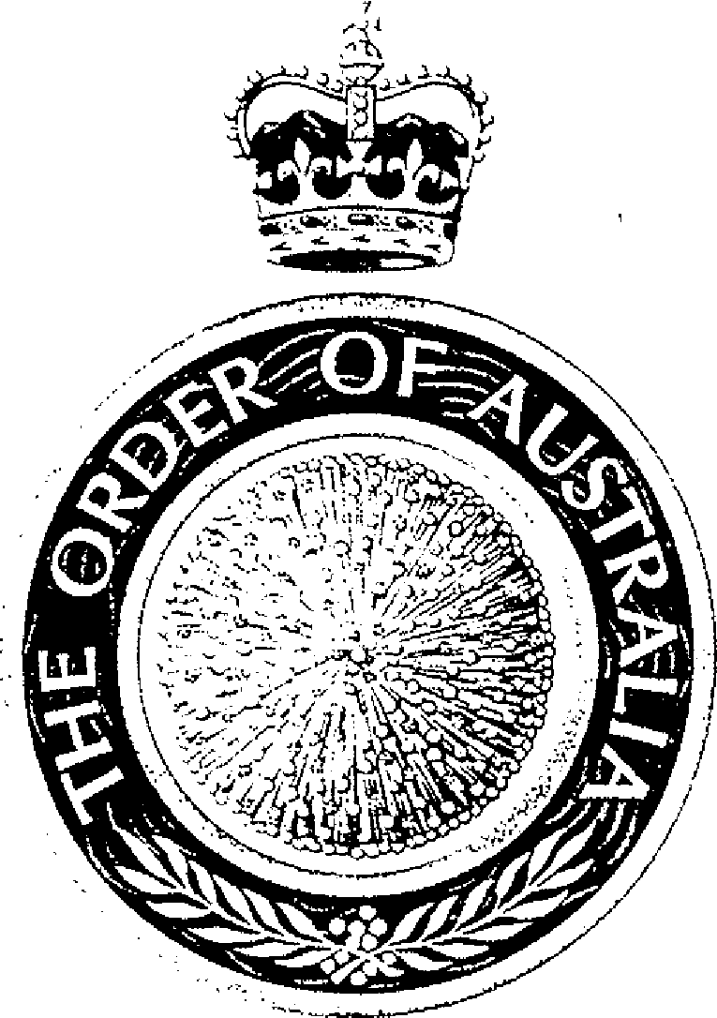
BILL HAYDEN
Governor-General of the Commonwealth of Australia
and Chancellor of
the Order of Australia
Dated 4th November 1993

I, WILLIAM GEORGE HAYDEN, Governor-General of the Commonwealth of Australia, acting under section 30 of the Constitution of the Order of Australia, revoke the Insignia Ordinance made on 1 February 1977 and make the following Ordinance.

Sealed with the Seal of the Order of Australia in the presence of:

D. STURKEY

Douglas Sturkey
Secretary of the
Order of Australia

Insignia Ordinance
Short Title
1. This ordinance may be cited as the Insignia Ordinance.
Interpretation
2. (1) In this Ordinance, “Constitution” means then Constitution of the Order of Australia.
(2) Unless the contrary intention appears, an expression used in the Constitution and in this Ordinance has the same meaning in this Ordinance as in the Constitution.
Definition of “member”
(3) A “member of the Order of Australia” means any person who has received the approval of The Sovereign to wear the Insignia of Knight or Dame, Companion, Officer, or Member or the Medal of the Order of Australia.
(4) A reference in this Ordinance to the Ribbon of the Order in relation to Insignia of a member of the Order is:
(a) in the case of a member of the Order in the General Division — a reference to the Ribbon of the Order in the General Division, and
(b) in the case of a member of the Order in the Military Division — a reference to the Ribbon of the Order in the Military Division.
Emblem of the Order
3. The Emblem of the Order is a single flower of mimosa, represented in the form of a convex disc.
Ribbon of the Order
4. (1) Ribbons of the Order in the General Division are of moire Royal blue material in three sizes, being 38 millimetres, 32 millimetres and 16 millimetres wide; the widest Ribbon having a central band 12 millimetres wide of scattered golden mimosa blossoms of various sizes, the other widths having the same pattern in proportion.
(2) Ribbons of the Order in the Military Division are of the sizes, colours and pattern described in sub-regulation 4 (1) with a gold band 1.5 millimetres wide on each edge.
Insignia of The Sovereign
5. The Insignia of The Sovereign of the Order is a Badge of the same material, fashion and size as the Breast Badge of a Knight or Dame of the Order but with such alterations as distinguish the Royal dignity.
Insignia of the Chancellor
6. The Insignia of the Chancellor of the Order is a Badge of the same material, fashion and size as the Breast Badge of a Knight or Dame of the Order but with such alterations and additions as The Sovereign approves.
Insignia of Knight and Dame
7. (1) The Insignia of a Knight of the Order consists of a Neck Badge and a Breast Badge.
(2) The Insignia of a Dame of the Order consists of a Neck (or Shoulder) Badge and a Breast Badge.
(3) The Neck Badge of a Knight and the Neck/Shoulder Badge of a Dame consists of the Emblem of the Order, approximately 60 millimetres in diameter, of gold, jewelled and having in the centre of its convex surface, within a circle of gold, a representation of the Arms of the Commonwealth of Australia in full colour on a background of blue with two branches of mimosa in gold, the whole ensigned with the Crown of Saint Edward in full colour.
(4) The Breast Badge of a Knight or Dame consists of the Emblem of the Order, approximately 80 millimetres in diameter, of gold, jewelled and having the same design and ensignment as the Insignia described in
sub-regulation 7 (3).
Manner of wearing Knight of Dame Insignia
(5) The Neck Badge of a Knight shall be worn about the neck suspended from the 16 millimetre Ribbon of the Order.
(6) The Neck/Shoulder Badge of a Dame shall be worn either as for a Knight as described in sub-regulation 7 (5) or, if preferred by the recipient, on the left shoulder suspended from the 38 millimetre wide Ribbon of the Order tied in a bow.
(7) The Breast Badge of a Knight or Dame shall be worn above the waist on the left side of the coat or outer garment.
Insignia of Companion
8. (1) The Insignia of a Companion of the Order is a Badge consisting of the Emblem of the Order, approximately 60 millimetres in diameter, of gold, jewelled, ensigned with the Crown of Saint Edward in full colour and having in the centre of its convex surface a circlet of blue enamel edged in gold, inscribed with the word “AUSTRALIA” in gold flanked by two sprigs of mimosa in gold.
Manner of wearing Companion Insignia
(2) Female recipients not in uniform may wear the Insignia as for the Neck/Shoulder Badge of a Dame as described in sub-regulation 7 (6). All other recipients wear the Insignia as for the Neck Badge of a Knight as described in sub-regulation 7 (5).
Insignia of Officer
9. (1) The Insignia of an Officer of the Order is a Badge consisting of the Emblem of the Order, approximately 55 millimetres in diameter, of gold-plated silver, ensigned with the Crown of Saint Edward in full colour and having in the centre of its convex surface the same design as the Insignia of a Companion as described in sub-regulation 8 (1).
Manner of wearing Officer Insignia
(2) Female recipients not in uniform may wear the Insignia as for the Neck/Shoulder Badge of a Dame as described in sub-regulation 7 (6). All other recipients wear the Insignia as for the Neck Badge of a Knight as described in sub-regulation 7 (5).
Insignia of Member
10. (1) The Insignia of a Member of the Order is a Badge consisting of the Emblem of the Order, approximately 45 millimetres in diameter, of gold-plated silver, ensigned with the Crown of Saint Edward in full colour and having in the centre of its convex surface a circlet of the same material as the Emblem containing the word “AUSTRALIA” flanked by two sprigs of mimosa.
Manner of wearing Member Insignia
(2) The Badge of a Member of the Order, when worn by women in uniform, and by men, shall be worn on the left breast suspended from the 38 millimetre wide Ribbon of the Order.
(3) The Badge of a member of the Order, when worn by women not in uniform, may be worn in the same manner as described in sub-regulation 10 (2), or if preferred by the recipient, may be worn on the left shoulder suspended from a Ribbon of the Order tied in a bow.
Medal of the Order
11. (1) The Medal of the Order consists of the Emblem of the Order, approximately 40 millimetres in diameter, of gold-plated silver, ensigned with the Crown of Saint Edward in gold-plated silver and having in the centre of its convex surface a circlet of the same material as the Emblem containing the word “AUSTRALIA” and two sprigs of mimosa.
Manner of wearing Medal Insignia
(2) The Medal of the Order, when worn by women in uniform, and by men, shall be worn on the left breast suspended from a bar attached to the 32 millimetre wide Ribbon of the Order.
(3) The Medal of the Order, when worn by women not in uniform, may be worn in the same manner as described in sub-regulation 11 (2) or if preferred by the recipient, may be worn on the left shoulder suspended from a bar attached to the 32 millimetre Ribbon of the Order tied in a bow.
Miniatures
12. (1) The miniature Insignia of the Order consists of the Emblem of the Order, approximately 20 millimetres in diameter, ensigned with the Crown of Saint Edward. The miniature for a Knight, Dame or Companion has a jewelled centre, that for an Officer or Member has an enamelled blue centre and that of the Medal has a plain gold centre.
Manner of wearing miniatures
(2) Miniatures are worn on the left breast suspended from the 16 millimetre wide Ribbon of the Order, either from a medal bar with miniatures of other awards held, or singly if it is the recipient’s only award. Women not in uniform may, if this is the only award, prefer to wear their miniature on the left shoulder attached to the 16 millimetre Ribbon of the Order tied in a bow, otherwise it should be worn with other miniatures mounted on a medal bar.
Lapel Badges
13. Lapel Badges of the Order consist of the Emblem of the Order, approximately 10 millimetres in diameter. The Lapel Badge for a Knight, Dame or Companion has a jewelled centre, that for an Officer or Member has an enamelled blue centre and that of the Medal has a plain gold centre.
Badge of Secretary
14. (1) The Badge of the Secretary of the Order has two crossed quills of
gold-plated silver surmounted by the Emblem of the Order, approximately 55 millimetres in diameter and also of gold-plated silver, the Emblem being ensigned with the Crown of Saint Edward in full colour and having in the centre of its convex surface a circlet of blue enamel edged with gold, inscribed with the word “AUSTRALIA” flanked by two sprigs of mimosa in gold.

Manner of wearing Badge of Secretary
(2) The Badge of the Secretary of the Order is worn:
(a) at ceremonies of the Order — suspended from a gold chain about the neck; and
(b) on other occasions — in the manner prescribed for the wearing of the Insignia of a Companion in the General Division.
Precedence
15. (1) An award of the Order in the General Division takes precedence over the same level of award in the Military Division.
(2) Insignia of the Order should be mounted in accordance with the Australian Order of Precedence of Honours and Awards as approved from time to time by The Sovereign and worn in accordance with the booklet “A Guide to the Wearing of Insignia” issued by the Office of the Official Secretary to the Governor-General.
Armorial Bearings
16. (1) In any Armorial Bearings granted by the Garter Principal King of Arms to a member of the Order, armorial indications of rank within the Order may be included in accordance with this sub-regulation.
(2) Knights and Dames may be granted supporters.
(3) A Knight, Dame, Companion or Officer of the Order may surround his or her armorial bearings with a circlet of the same design and colours as the circlet that is at the centre of the Badge of a Companion of the Order and may suspend therefrom a representation of the Ribbon of the Order together with:
(a) in the case of a Knight or Dame — a representation of the Neck Badge of a Knight; and
(b) in the case of a Companion or Officer — a representation of his or her Badge.
(4) A Member of the Order may suspend a representation of the Badge of Member and the Ribbon of the Order from the bottom of the escutcheon containing his or her armorial bearings.
(5) The holder of a Medal of the Order may suspend a representation of the Medal and the Ribbon of the Order from the bottom of the escutcheon containing his or her armorial bearings.
Return of Insignia on Promotion
17. (1) A person, previously appointed to the Order at the level of Member or Officer, who is subsequently appointed to a higher class of membership in the same Division, shall wear the Insignia of the higher award only. The person shall also return to the Secretary of the Order the Insignia of the lower class of membership.
Medal Holder to Retain Insignia on Promotion
(2) A holder of the Medal of the Order who is subsequently appointed to the Order at any level in the same Division shall wear the Insignia of the higher award only. It is not necessary to return to the Secretary of the Order the Insignia of the Medal of the Order, but this should not be worn.
Member in both Divisions to retain Insignia in both Divisions
18. (1) A person who has been appointed at the level of Member or higher to both the General Division and the Military Division of the Order is entitled to retain and wear the Insignia of both Divisions.
(2) A holder of the Medal of the Order in one Division who is subsequently appointed to the Order at any level in the other Division is entitled to retain and wear the Insignia of both Divisions.
Badge of Office to be restored on change of Office Holder
19. Where a person ceases to be an official of the Order the Badge of Office issued to that person shall be restored for the service of the Order.
Investitures
20. (1) A person appointed to the Order or a recipient of the Medal of the Order shall be invested with the Insignia of the Order by The Sovereign or the Chancellor of the Order or by such other person as The Sovereign or the Chancellor may authorize.
Warrant of Dispensation
(2) The Chancellor may, by Warrant under the Seal of the Order, permit the ceremony of Investiture to be dispensed with in respect of any person named in the Warrant.

