ELIZABETH R
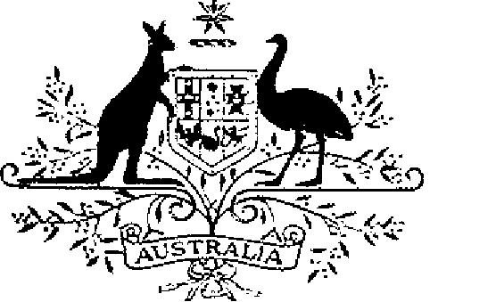

ELIZABETH THE SECOND, by the Grace of God Queen of Australia and Her other Realms and Territories, Head of the Commonwealth:

TO ALL to whom these Presents shall come,
GREETING:
WHEREAS it is desirable that there be instituted an Australian decoration for the purpose of according recognition to members of the Defence Force and certain other persons for outstanding performance of nursing duties:
KNOW YOU that We do by these Presents institute a decoration to be designated and styled the Nursing Service Cross:
AND WE DO ordain that the award of the Nursing Service Cross shall be governed by the Regulations set out in the Schedule.
IN WITNESS whereof We have caused these Our Letters to be made Patent.
GIVEN under the Great Seal of Australia at Our Court at St James’s on 18 October 1989
By Her Majesty’s Command,
L.S..
BOB HAWKE
Prime Minister

SCHEDULE

NURSING SERVICE CROSS REGULATIONS
Short title
1. These Regulations may be cited as the Nursing Service Cross Regulations.
Interpretation
2. In these Regulations—
“decoration” means:
(a) the Nursing Service Cross; or
(b) a bar to the Cross.
“Defence Force” has the same meaning as in the Defence Act 1903.
“Minister” means the Minister of State for Defence.
Conditions for award of the decoration
3. The Nursing Service Cross shall be awarded only for outstanding devotion and competency in the performance of nursing duties or for an act of exceptional dedication in the performance of such duties.
4. Each decoration may be awarded posthumously.
5. The persons to whom the decoration may be awarded are—
(a) a member of the Defence Force; and
(b) other persons determined by the Minister for the purposes of this regulation.
6. Any subsequent award of the Nursing Service Cross to the same person shall be made in the form of a bar to the Cross.
Making of awards
7. Awards of the decoration shall be made by the Governor-General on the recommendation of the Minister.
Designation
8. (1) A person to whom the Nursing Service Cross has been awarded is entitled to have the letters “NSC” placed after the person’s name on all occasions when the use of such letters is customary.
(2) Where a person has been awarded a bar to the Nursing Service Cross, the person is entitled to have placed after the letters prescribed by this Regulation in respect of the Cross the words “and Bar” or the words “and Bars”, as the case may be.
Design of the decoration
9. The design of the decoration shall be as prescribed.
Wearing of the decoration
10. The manner of wearing the decoration shall be as determined by the Governor-General.
Registrar of Awards
11. (1) There shall be a Registrar of Awards who shall be appointed by the Governor-General and who shall maintain a Register of the names of persons to whom the decoration has been awarded.
(2) The Registrar shall keep such other records relating to the award of the decoration as the Governor-General directs.
Cancellation and reinstatement
12. (1) The Governor-General may cancel an award of the decoration and may reinstate an award so cancelled.
(2) Where an award of the decoration is cancelled, the name of the person to whom the award was made shall be erased from the Register and the person shall return the decoration to the Registrar.
(3) Where an award that has been cancelled pursuant to sub-regulation (1) is reinstated, the Registrar shall restore the entry or entries in the Register that had been erased.

