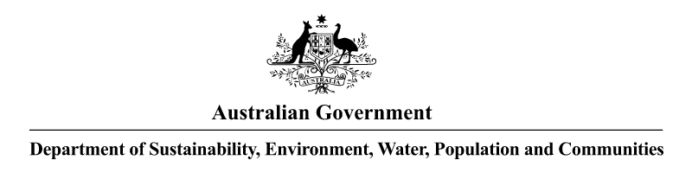
NOTICE OF APPLICATION RECEIVED UNDER THE
HAZARDOUS WASTE (REGULATION OF EXPORTS AND IMPORTS) ACT 1989
Pursuant to Section 33 of the Hazardous Waste (Regulation of Exports and Imports) Act 1989, notice is given that an application has been received from Hazmat Services Pty Ltd (Hazmat Services), 42 Heather Street, Heatherbrae, New South Wales 2324. The application relates to the import of up to 100 000 litres of wase non-halogenated solvents from Total Waste Management Ltd, Section 79, Lot 19, Merrie England Road, Korobosea, National Capital District, 131, Papua New Guinea. The applicant proposes importing the non-halogenated solvents for use as an ingredient in the production of fuel for cement kilns.
Under the proposed transboundary movement the waste would be transported by road to Port Moresby in Papua New Guinea and then shipped by sea direct to Newcastle in Australia. From there, the waste would be transported by road to the Hazmat Services waste management facility at 42 Heather Street, Heatherbrae, New South Wales 2324 for storage. The waste would then be transported by road to the Geocycle SPF Pty Ltd (Geocycle) facility at 1/92-94 Ordish Road, Dandenong, Victoria 3175 for use as an ingredient in the production of fuel for cement kilns.
The transboundary movements would take place in six (6) shipments over twelve (12) months commencing from the date of the permit, if granted.

Dr Barry Reville
Delegate to the Minister
Assistant Secretary
Environment Protection Branch
22 October 2012

