Government House

CANBERRA ACT 2600

1 November 2012

It is notified for general information that Her Majesty The Queen has approved the award of the Victoria Cross for Australia to:

Corporal Daniel KEIGHRAN
For the most conspicuous acts of gallantry and extreme devotion to duty in action in circumstances of great peril at Derapet, Uruzgan Province, Afghanistan as part of the Mentoring Task Force One on Operation SLIPPER.

By Her Excellency’s Command

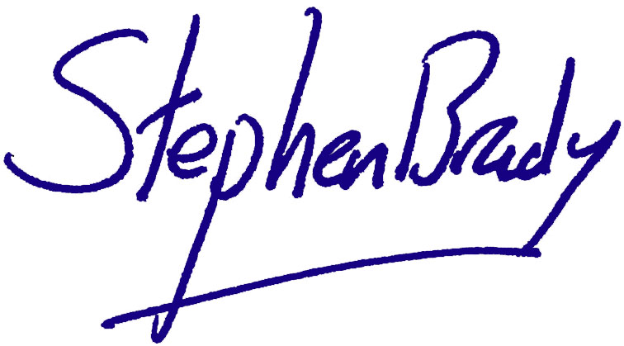

Stephen Brady CVO
Official Secretary to the Governor-General

Corporal Daniel Alan Keighran, WA

For the most conspicuous acts of gallantry and extreme devotion to duty in action in circumstances of great peril at Derapet, Uruzgan Province, Afghanistan as part of the Mentoring Task Force One on Operation SLIPPER.

On 24 August 2010 Corporal Keighran of the 6th Battalion Royal Australian Regiment, was a member of a partnered fighting patrol with soldiers of the Afghan National Army’s 1st Kandak, 4th Brigade, 205th (Hero) Corps which was engaged by a prolonged, numerically superior and coordinated enemy attack from multiple firing points. Corporal Keighran, with complete disregard for his own safety, broke cover on multiple occasions to draw intense and accurate enemy fire to identify enemy locations and direct return fire from Australian and Afghan fire support elements. During one of these occasions, when his patrol sustained a casualty, he again, on his own initiative and in an act of exceptional courage moved from his position of cover to deliberately draw fire away from the team who were treating the casualty. Corporal Keighran remained exposed and under heavy fire in order to direct suppressing fire and then assist in the clearance of the landing zone to enable evacuation of the casualty. These deliberate acts of exceptional courage to repeatedly expose himself to accurate and intense enemy fire, thereby placing himself in grave danger, ultimately enabled the identification and suppression of enemy firing positions. In circumstances of great peril Corporal Keighran’s actions were instrumental in permitting the withdrawal of the combined Australian and Afghan patrol with no further casualties.

