Maritime Transport and Offshore Facilities Security Act 2003

Notice of declaration of security regulated port – PORT OF NEWCASTLE

I, MICHAEL WILLIAM ROWE, Regional Director, Transport Security Operations, Office of Transport Security, under subsection 13(1) of the Maritime Transport and Offshore Facilities Security Act 2003 (the Act):

REVOKE the declaration of the security regulated port of Newcastle Port as published in the Gazette (No. 22, 2 June 2004) on Line no. 25 of Column A (the port) and shown on the map identified as ‘25. Newcastle Port’ on page 1453; and

DECLARE that the area of the port of Port of Newcastle intended for use either wholly or partly in connection with the movement, loading, unloading, maintenance or provisioning of security regulated ships, the boundaries of which are shown on the attached map and descriptions, to be a security regulated port.

This Notice commences upon publication in the Gazette.

Date: 2 November 2012

Michael Rowe
Delegate of the Secretary of the
Department of Infrastructure and Transport
This map shows the boundaries of the security regulated port for the purposes of the Maritime Transport & Offshore Facilities Security Act 2003. This map is not intended for navigational purposes. Further information can be obtained from the Department of Infrastructure, and Transport, Office of Transport Security (OTS), GPO Box 594, Canberra ACT 2601, or phone the Transport Security Coordination Centre on 1300 307 288.

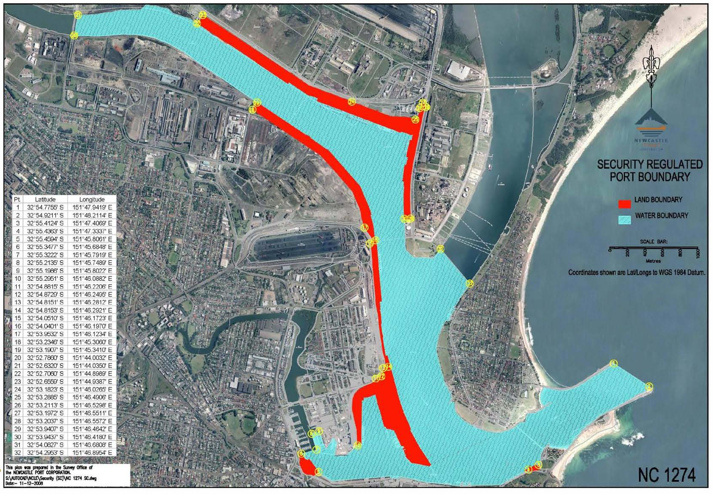
This map shows the boundaries of the security regulated port for the purposes of the Maritime Transport & Offshore Facilities Security Act 2003. This map is not intended for navigational purposes. Further information can be obtained from the Department of Infrastructure, and Transport, Office of Transport Security (OTS), GPO Box 594, Canberra ACT 2601, or phone the Transport Security Coordination Centre on 1300 307 288.
Port of Newcastle
Security Regulated Port Boundary Description – Port of Newcastle
The Security Regulated Port Boundary for the Port of Newcastle is the area inside a line commencing at a point on the mean high water mark at the North Eastern end of the Northern breakwater at the mouth of the Hunter River the coordinates of which are approximately (1) 32° 54.775’ S, 151° 47.9419’ E
Then South Easterly approximately 500m to a point on the mean high water mark at the North Eastern end of the Southern breakwater at the mouth of the Hunter River the coordinates of which are approximately (2) 32° 54.9211’ S, 151° 48.2114’ E
Then generally South Westerly approximately 1.7km along the mean high water mark of the North Western side of the Southern breakwater to a point on the mean high water mark closest to the most North Eastern corner of the Pilot Station at coordinate (3) 32° 55.4124’ S, 151° 47.4069’ E
Then Southerly inland following the boundary fence line of the Newcastle Port Corporation Pilot Station to a point on the mean high water mark on the Southern side of the Hunter River at coordinate (4) 32° 55.4363’ S, 151° 47.3337’ E
Then following the mean high water mark along the Southern side of the Hunter river approximately 2.5km to the most South Easterly corner of the Throsby Berth at coordinate (5) 32° 55.4594’ S, 151° 45.8061’ E
Then generally South Westerly inland following the boundary fence of the Throsby Wharf to a point at the Northern corner of the Throsby Wharf on the mean high water mark at coordinate (6) 32° 55.3477’ S, 151° 45.6848’ E
Then following an imaginary line Easterly approximately 175m to the South West corner of the Forgacs floating dock at coordinate (7) 32° 55.3222’ S, 151° 45.7919’ E
Then following the Western side wall boundary of the Forgacs floating dock to the North Western corner at coordinate (8) 32° 55.2135’ S, 151° 45.7489’ E
Then following an imaginary line North Easterly to a point on the mean high water mark at coordinate (9) 32°55.1986’ S, 151° 45.8022’ E
Then following the mean high water mark Southerly around to a point on the mean high water mark approximately adjacent to the Southern most corner of the Western basin berth No. 3 at coordinate (10) 32° 55.2951’ S, 151° 46.0882’ E
Then following the boundary fence line of the Newcastle Port Corporation property in a Northerly direction for approximately 1km to a point where the fence line ends at coordinate (11) 32° 54.8815’ S, 151°46.2206’ E, then following an imaginary line in a North Easterly direction to the North East side of the roadway at the South West corner of the Carrington Facilities terminal fence line at coordinate (12) 32° 54.8729’ S, 151° 46.2495’ E
Then following the fence line in a North Easterly direction for approx 150m to a point where the fence turns Easterly at coordinate (13) 32° 54.8151’ S, 151° 46.2812’ E
Then following the fence line Easterly approx 10m to a point where the fence line turns Northerly at coordinate (14) 32° 54.8153’ S, 151° 46.2921’ E
Then following the fence line in a Northerly direction for approximately 1.425km to approximately adjacent to the Port Waratah Coal Services gatehouse at coordinate (15) 32° 54.0510’ S, 151° 46.1723’ E
Then following a North Easterly direction to approximately the North West corner of the access ramp at Dyke Berth No. 6 at coordinate (16) 32° 54.0401’ S, 151° 46.1970’ E
Then following the Eastern side of the roadway in a North Westerly direction to coordinate (17) 32° 53.9532’ S 151° 46.1234’ E then following an imaginary line in a North Westerly direction 100m from the mean high water mark for approximately 2km to coordinate (18) 32° 53.2346’ S 151° 45.3060’ E
Then turning in a North Easterly direction towards the mean high water mark at coordinate (19) 32° 53.1907’ S 151° 45.3410’ E
Then following the mean high water mark North West up the South arm of the Hunter River to the Eastern side of the Tourle Street bridge at coordinate (20) 32° 52.7860’ S, 151° 44.0032’ E, following the bridge North to the Northern side of the South arm of the Hunter River at the mean high water mark at coordinate (21) 32° 52.6320’ S, 151° 44.0350’ E
Then following the Northern side of the South arm of the Hunter River at the mean high water mark to the most Western end of the Newcastle Coal Infrastructure Group (NCIG) property at coordinate (22) 32° 52.7060’ S, 151° 44.8989’ E
Then heading inland North East to the North Western corner boundary of the NCIG property at coordinate (23) 32° 52.6559’ S, 151° 44.9387’ E
Then following the fence line closest to Cormorant Road heading in a South Easterly direction for approximately 1.95km to a point on the fence line where the fence line splits closest to coordinate (24) 32° 53.1823’ S, 151° 46.0265’ E
Then following the internal fence line in a South Easterly direction for approx 800m to the point where the fence turns Northerly at coordinate (25) 32° 53.2885’ S, 151° 46.4906’ E
Then following the fence line North approx 155m to a point where the fence turns North East at coordinate (26) 32° 53.2113’ S, 151° 46.529’ E then following the fence line approx 42m to a point closest to Heron Road at coordinate (27) 32° 53.1972’ S, 151° 46.5511’ E then following the fence line South East parallel to Heron Road approx 15m to the point where the fence turns Southerly at coordinate (28) 32° 53.203’ S, 151° 46.5572’ E
Then following the fence line in a Southerly direction adjacent to Heron Road for approx 1.25km to the South Eastern most corner of the woodchip stockpile property (Sawmillers) at coordinate (29) 32° 53.9407’ S, 151° 46.464’ E then following the fence line West for approx 100m to a point on the mean high water mark on the South arm of the Hunter River at coordinate (30) 32° 53.943’ S, 151° 46.418’ E
Then following the mean high water mark South around the Southern end of Walsh Point, Kooragang Island for approx 800m to coordinate (31) 32° 54.0827’ S, 151° 46.6808’ E
Then following an imaginary line South East across the North arm of the Hunter River approximately 530m to at point on the mean high water mark at coordinate (32) 32° 54.2953’ S 151° 46.8954’ E
Then heading South West following the mean high water mark to a point on the mean high water mark at the Eastern end of Southern side of the Northern breakwater at the mouth of the Hunter River at coordinate (1) 32° 54.7755’ S, 151° 47.9419’ E.

