COMMONWEALTH OF AUSTRALIA

Section 708
Offshore Petroleum and Greenhouse Gas Storage Act 2006

APPLICATION FOR A PETROLEUM PIPELINE LICENCE

I, GRAME ALBERT WATERS, the National Offshore Petroleum Titles Administrator, on behalf of the Commonwealth – Western Australia Offshore Petroleum Joint Authority, give notice pursuant to Section 708 of the Offshore Petroleum and Greenhouse Gas Storage Act 2006 that an application has been received from:

Woodside Energy Ltd
ABN 63 005 482 986

BHP Billiton (North West Shelf) Pty Ltd
ABN 41 004 514 489

BP Developments Australia Pty Ltd
ABN 54 081 102 856

Chevron Australia Pty Ltd
ABN 29 086 197 757

Japan Australia (MIMI) Pty Ltd
ABN 18 006 303 180

Shell Development (Australia) Pty Ltd
ABN 14 009 663 576

for a licence to construct a petroleum related pipeline from Start Point (POINT A) (GDA94) Zone 50, Easting: 383,723.09 mE, Northing: 7,814,441.36 mN (TPA MANIFOLD) to End Point (POINT B) (GDA94) Zone 50, Easting: 387,599.58 mE, Northing: 7,826,720.90 mN (GWA TIE-IN SPOOL FLANGE), for the conveyance of multiphase commingled wet gas and condensate from multiple hydrocarbon reservoirs for a distance of approximately 14.5 km. Refer to attached map for route detail.

This notice takes effect on the day in which it appears in the Australian Government Gazette.

Made under the Offshore Petroleum and Greenhouse Gas Storage Act 2006 of the Commonwealth of Australia.

GRAEME ALBERT WATERS
TITLES ADMINISTRATOR
APPLICATION FOR A PETROLEUM PIPELINE LICENCE
Greater Western Flank 1 (GWF-1) Pipeline
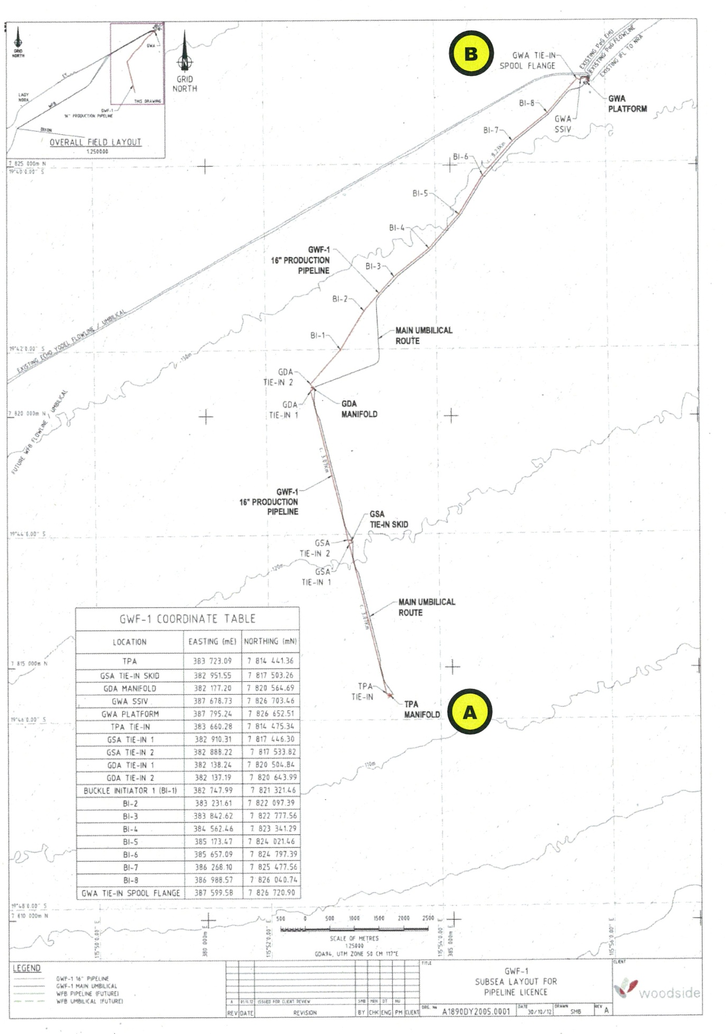
Proposed Pipeline Route Map

