Unique Identifying Number:
EPBC303DC/SFS/2012/67

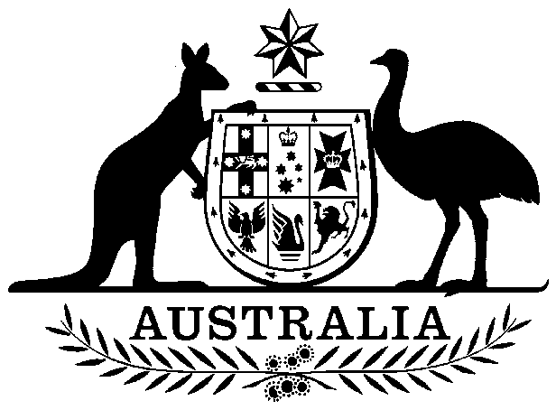
COMMONWEALTH OF AUSTRALIA

Environment Protection and Biodiversity Conservation Act 1999

Amendment of List of Exempt Native Specimens

I, GEOFF RICHARDSON, Assistant Secretary, Marine Biodiversity and Biosecurity Branch, as Delegate of the Minister for Sustainability, Environment, Water, Population and Communities, pursuant to subsection 303DC(1) of the Environment Protection and Biodiversity Conservation Act 1999 (EPBC Act), hereby amend the list of exempt native specimens established under section 303DB of the EPBC Act by deleting from the list the following item that was included in the list on 24 October 2008 and any associated notations:

- Specimens that are or are derived from fish or invertebrates, other than specimens that belong to species listed under Part 13 of the EPBC Act, taken in the Western Australian Marine Aquarium Fish Managed Fishery, as defined in the management regime in force under the Western Australia Fish Resources Management Act 1994 and the Western Australia Fish Resources Management Regulations 1995.

Dated this 21st day of December 2012

……………………Geoff Richardson……………………
Delegate of the Minister for Sustainability, Environment, Water, Population and Communities

