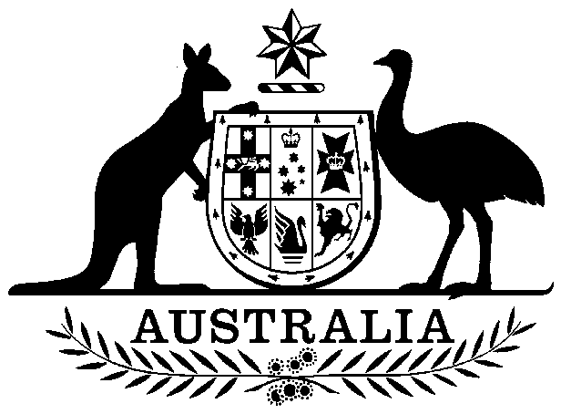
COMMONWEALTH OF AUSTRALIA

Environment Protection and Biodiversity Conservation Act 1999

Amendment of List of Exempt Native Specimens

I, GEOFF RICHARDSON, Assistant Secretary, Marine Biodiversity & Biosecurity Branch, as Delegate of the Minister for Sustainability, Environment, Water, Population and Communities pursuant to subsection 303DC(1) of the Environment Protection and Biodiversity Conservation Act 1999 (EPBC Act), hereby amend the list of exempt native specimens established under section 303DB of the EPBC Act by including in the list the following:

- specimens that are or are derived from fish or invertebrates, other than:
- specimens that belong to species listed under Part 13 of the EPBC Act, and
- specimens that belong to taxa listed under section 303CA of the EPBC Act,
taken in the Western Australian Marine Aquarium Fish Managed Fishery, as defined in the Western Australian Fish Resources Management Act 1994 and the Western Australian Fish Resources Management Regulations 1995, and in accordance with permits issued under the Western Australian Fish Resources Management Act 1994
with a notation that inclusion of the specimens in the list is subject to the following restrictions or conditions:

- the specimen, or the fish or invertebrate from which it is derived, was taken lawfully; and

- the specimens are covered by the declaration of an approved wildlife trade operation under section 303FN of the EPBC Act in relation to the fishery.

Dated this 21st day of December 2012

………………………Geoff Richardson……………………
Delegate of the Minister for Sustainability, Environment, Water, Population and Communities

