***National Transmission Network Sale Act 1998***

**Declaration of the transfer of an asset to Broadcast Australia Pty Limited**

**1. Definitions and Interpretation**

**1.1 Definitions**

“Company” means Broadcast Australia Pty Limited ACN 086 048 562;

“Transfer Time” means the beginning of the day after publication of a copy of this declaration in the Government Notices Gazette.

**1.2 Interpretation**

In this declaration, “right” includes a right that is “land” for the purposes of the *Lands Acquisition Act 1955* or an “interest” for the purposes of the *Lands Acquisition Act 1989*.

**2. Declarations**

I, PENELOPE YING YEN WONG, acting under section 9(1) of the *National Transmission Network Sale Act 1998*, declare that:

* 1. the following Commonwealth asset (***the Asset***):

the right acquired by the Commonwealth of Australia as described in the ‘Notice of the Acquisition of Land by the Commonwealth’ scheduled to this declaration;

vests in the Company at the Transfer Time without any conveyance, transfer or assignment; and

* 1. at the Transfer Time, the Company becomes the Commonwealth’s successor in law in relation to the Asset.

Dated the 17th day of January 2013.

Signed by

PENELOPE YING YEN WONG

Minister for Finance and Deregulation

**SCHEDULE**

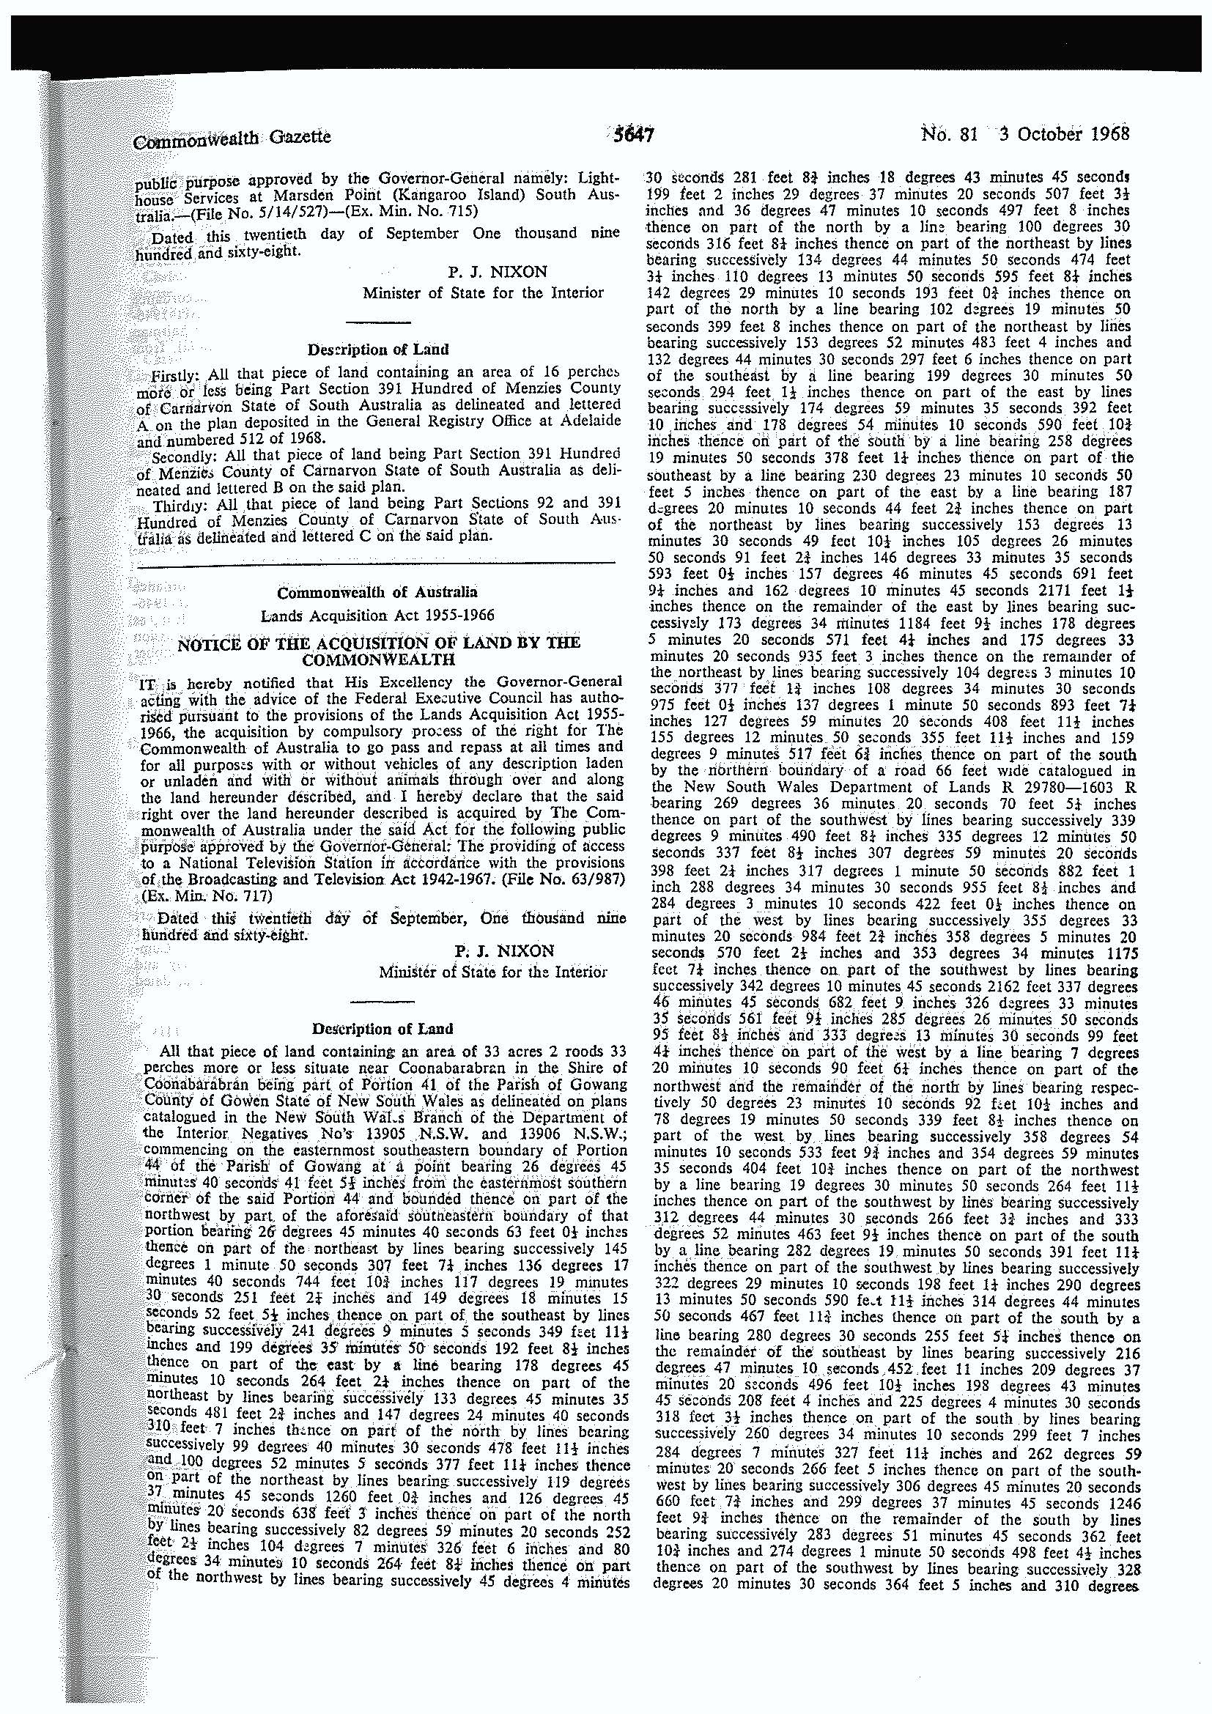This Notice was published in the Commonwealth Gazette on 3 October 1968, pursuant to the *Lands Acquisition Act 1955*.

