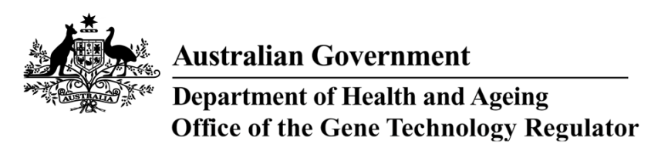
29 April 2013

invitation to comment on

genetically modified cotton field TRIAL
Australia’s gene technology regulatory system is designed to protect the health and safety of people and the environment by identifying risks posed by, or as a result of, gene technology and managing those risks.
The Gene Technology Regulator is currently assessing licence application DIR 120 from Monsanto Australia Ltd for a limited and controlled release (field trial) of cottons that have been genetically modified for insect resistance and herbicide tolerance.
The primary purpose of the field trial is to assess the agronomic performance of the GM cottons under Australian field conditions. The trial is proposed to take place between October 2013 and October 2019 on up to 10 sites of 10 hectares (ha) for the first two years and up to 20 sites of 30 ha in subsequent years. Sites are to be selected from 56 possible local government areas (LGAs) in Western Australia, NSW and Queensland. The GM cottons would not be permitted in human food or animal feed.
A consultation Risk Assessment and Risk Management Plan (RARMP) has been prepared, which concludes that the proposed release would pose negligible risk to human health and safety or to the environment. A range of draft licence conditions would limit the size, location and duration of the release, as well as restrict the spread and persistence of the GMOs and the introduced genetic material.
The Regulator welcomes written submissions in order to finalise the RARMP, which will then form the basis for a decision on whether or not to issue the licence. The consultation RARMP and related documents can be obtained from the website under ‘What’s New’ or by contacting the Office. Please quote application DIR 120 in any correspondence.
Submissions should be received by close of business on 11 June 2013.
Office of the Gene Technology Regulator, MDP 54, GPO BOX 9848 CANBERRA ACT 2601
Telephone: 1800 181 030 Facsimile: 02 6271 4202 E-mail: ogtr@health.gov.au
Website: http://www.ogtr.gov.au

