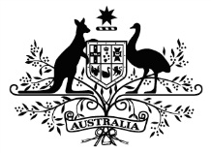

COMMONWEALTH OF AUSTRALIA

***Export Control Act 1982***

Export Control (Unprocessed Wood) Regulations

**Notice of Approval of Plantation Forestry Codes of Practice in New South Wales, Victoria, Western Australia, Tasmania, the Australian Capital Territory and the Northern Territory**

I, SID SIDEBOTTOM, Parliamentary Secretary for Agriculture, Fisheries and Forestry, having found, in accordance with subsection 4B(2) of the Export Control (Unprocessed Wood) Regulations, that the plantation forestry codes of practice in the States of New South Wales, Victoria, Western Australia and Tasmania; the Australian Capital Territory; and the Northern Territory, would satisfactorily protect environmental and heritage values, give notice that on the   
 second day of May 2013, I approved those codes of practice in accordance with subsection 4B(1) of those regulations.

Date 2 May 2013

signature of the Australian Government Parliamentary Secretary for Agriculture, Fisheries and Forestry, the Hon. Sid Sidebottom MP

Sid Sidebottom

Parliamentary Secretary for Agriculture, Fisheries and Forestry