***LANDS ACQUISITION ACT 1989***

**PRE-ACQUISITION DECLARATION**

1. **Acquisition**

In accordance with the *Lands Acquisitions Act 1989,* I am considering the acquisition of the interests in land specified in paragraph 3 for the public purpose described in paragraph 4. The Murray-Darling Basin Authority is the acquiring authority.

1. **The land**

The land is the property described as part of Crown Allotment 32 Section 8 in Title Plan TP525340K located in the Parish of Gunbower, Victoria, identified in Schedules 1-3. This property is located at the end of Hipwell Road, adjacent to Gunbower National Park, approximately 12 kilometres south east of Cohuna, Victoria, as set out in Schedule 1.

1. **The interests in the land**

This declaration relates to the acquisition of an easement for flooding identified as “E-1” in Schedules 1-3, in the land specified in paragraph 2.

1. **The public purpose**

The public purpose of the acquisition is to enable the Murray-Darling Basin Authority to give directions for, and to manage, the release of water from the Gunbower Creek into the Gunbower Forest for environmental watering purposes.

1. **Suitability for development for use for a public purpose**

The land is located on the boundary of the Gunbower Forest and forms part of the natural floodplain. As a result, it is suitable for the public purpose described in paragraph 4.

1. **Particulars of proposed development for use**

The proposed releases will be from Gunbower Creek into the Gunbower Forest at a rate of up to, but not exceeding, 1,650 megalitres in any period of 24 hours measured at the Hipwell Rd Regulator, for a minimum of 90 days, six out of every 10 years on a rolling basis.

1. **Reasons why the land appears to be suitable for the proposed development for use**

The land specified in paragraph 2 is suitable for the use described in paragraph 6 because it borders the Gunbower Forest. The easement specified in paragraph 3 will provide security for the proposed environmental watering of Gunbower Forest in the event that water released from Gunbower Creek encroaches on and inundates the land.

Dated this 28 day of May 2013.

Ned Rokvic

Delegate of the Special Minister of State

Director Land Acquisitions, Native Title and Mining Section

Heritage, Environment and Land Policy Branch

Department of Finance and Deregulation

**Note: This Pre-Acquistion Declaration signifies that the Murray-Darling Basin Authority is considering an acquisition of the interest in land specified in paragraph 3. It does NOT mean the interest in land has been acquired.**

**Schedule 1**

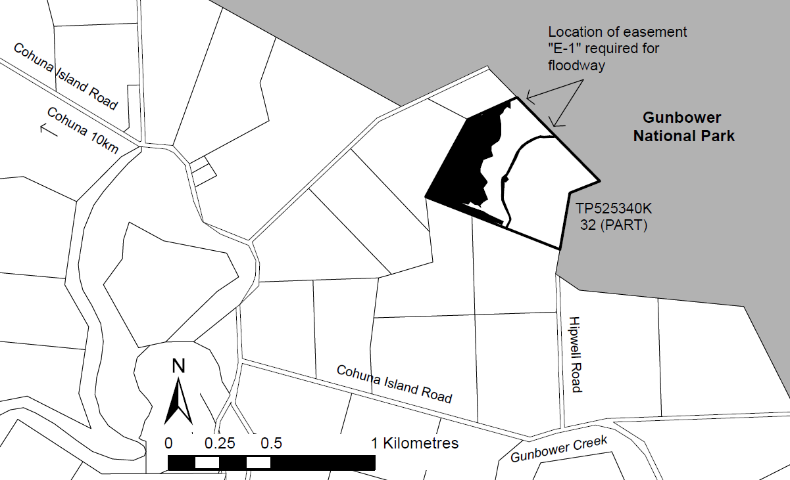

**Schedule 2** **Schedule 3**

