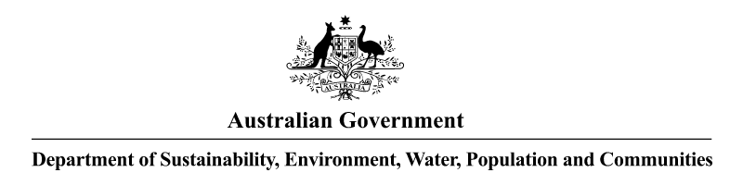 **NOTICE OF DECISION TO GRANT SPECIAL TRANSIT PERMIT UNDER THE   
*HAZARDOUS WASTE (REGULATION OF EXPORTS AND IMPORTS) ACT 1989***

Pursuant to section 33 of the *Hazardous Waste (Regulation of Exports and Imports) Act 1989*, notice is given that on 28 June 2013, permit number AUH367116S was granted to   
Metalman NZ Ltd (Metalman), 1 Rangi Road, Takanini, Auckland in New Zealand   
(Telephone +64 09 274 4567; Fax: +64 09 274 8567).

The particulars of the permit are as follows:

(a) the hazardous waste to be transited is used lead acid batteries;

(b) the quantity of the waste to be transited is a maximum of 10 000 tonnes;

(c) at all times involving transfer and transportation, the waste must be packed and transported according to the applicable regulations and/or requirements based on the United Nations Committee of Experts on the Transport of Dangerous Goods ‘Recommendations on the Transport of Dangerous Goods’;

(d) the waste is to be transported in up to forty-eight (48) shipments:

(i) by road from the Metalman facility located at 1 Rangi Road, Takanini, Auckland in New Zealand to the port(s) of exit in New Zealand;

(ii) by ship from New Zealand, transiting the Australian ports of Sydney and Melbourne, en route to the Republic of Korea;

(e) the waste will be transported by road by Metalman, and by ship by   
CFR Line New Zealand, 270 Nielson Street, Oneguna, Auckland in New Zealand   
(Telephone +64 09 475 5185; Fax: +64 09 475 5186);

(f) no shipment is authorised under this permit before the date above or after twelve (12) months from the date above.

The permit includes and is subject to conditions.

Andrew McNee

Assistant Secretary

Environment Protection Branch

Department of Sustainability, Environment, Water, Population and Communities

Subject to the *Administrative Appeals Tribunal Act 1975*, a person or persons whose interests are affected by this decision may, within 28 days, make an application in writing to the Department of Sustainability, Environment, Water, Population and Communities requesting the reasons for the decision.

An application for independent review of the decision may be made to the Administrative Appeals Tribunal on payment of the relevant fee by the applicant within 28 days of receipt of the reasons for the decision, or within 28 days of this notice if the reasons for the decision are not sought. Applications should be made to the Deputy Registrar, Administrative Appeals Tribunal in your capital city, see under Commonwealth Government Section in the White Pages. Further information or enquiries should be directed to:

Director, NPI & Hazardous Waste Section

Department of Sustainability, Environment, Water, Population and Communities

GPO Box 787 CANBERRA ACT 2601

Telephone 1800 803 772, Facsimile (02) 6274 1164, or by E-mail at hwa@environment.gov.au.