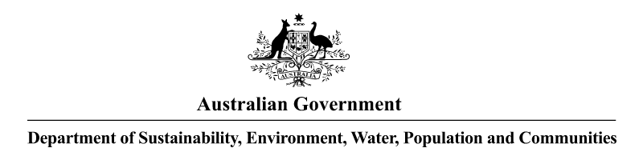

**NOTICE OF APPLICATION RECEIVED UNDER THE   
*HAZARDOUS WASTE (REGULATION OF EXPORTS AND IMPORTS) ACT 1989***

Pursuant to Section 33 of the *Hazardous Waste (Regulation of Exports and Imports) Act 1989*, notice is given that an application has been received from Sterihealth Limited, 110 Doherty’s Road, Laverton North, Victoria 3026 to import up to 150 000 kilograms of waste solids containing toxic liquid N.O.S. (clothes, sharps and vials of contaminated waste with cytotoxic medicines) from Transpacific Technical Services (NZ) Ltd, 16-30 Neals Road, East Tamaki, Auckland, New Zealand. The waste is destined for disposal operation D10 - Incineration on land.

The transboundary movement would take place in up to twenty (20) shipments over twelve (12) months commencing from the date of the permit, if granted. The movements will transit no other ports on their voyage to the Port of Melbourne, Australia.

Andrew McNee

Assistant Secretary

Environment Protection Branch

2 July 2013