

**Government House**

**CANBERRA ACT 2600**

##### 8 July 2013

**ORDER OF AUSTRALIA**

It is notified for general information that the Administrator of the Government of the Commonwealth of Australia has accepted the resignation as a member of the Order of Australia in the General Division with effect from 13 June 2013:

**Mr Daniel BELL**

To cease to have the award of the Medal of the Order of Australia

# By Her Excellency’s Command

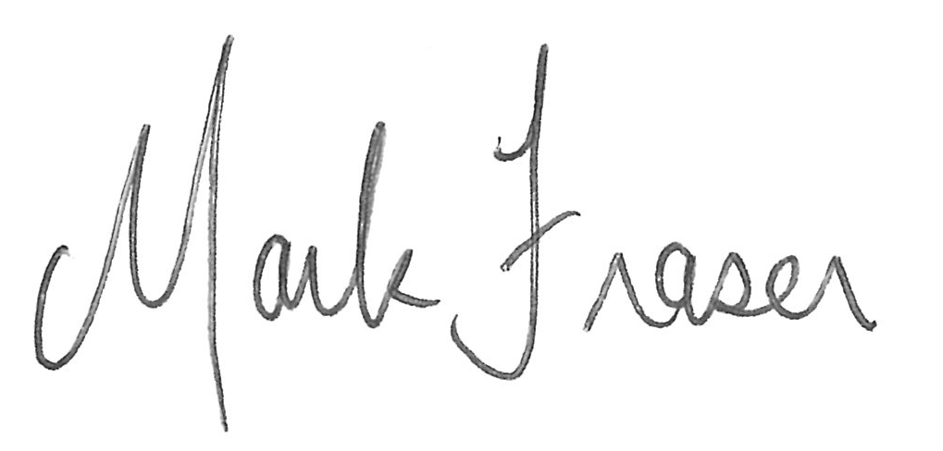

#### Mark Fraser OAM

Acting Official Secretary to the Governor-General and

Secretary of the Order of Australia