A05246


Aviation Transport Security Act 2004

NOTICE OF DECLARATION OF SECURITY CONTROLLED AIRPORT AND AIRSIDE AREA – BLACKALL AIRPORT

I, ROGER VAUGHAN LONIE, Acting Regional Director, Transport Security Operations, Office of Transport Security:

REVOKE, under subsection 28(2) of the Aviation Transport Security Act 2004 (the Act), Notice A03074 which declared Blackall Airport as a security controlled airport as published in the Gazette (No. GN/S 80, 28 June 2012);

DECLARE, under subsection 28(2) of the Act, that Blackall Airport is a security controlled airport, the boundaries of Blackall Airport are shown on the attached map which forms part of this notice; and

ESTABLISH, in accordance with section 29 of the Act, an airside area for Blackall Airport being that area indicated as the airside area on the attached map.

This Notice commences upon publication in the Gazette.

Date: 24 July 2013

Roger Lonie
Delegate of the Secretary of the
Department of Infrastructure and Transport

Note:
- Gazette means the Commonwealth of Australia Gazette
- This Notice remains in force until otherwise revoked in writing and upon subsequent publication in the Gazette.

RAT208-01

Blackall-Tambo Regional Council - Boundary of Security Controlled Airport & Airside Area – Blackall Airport.

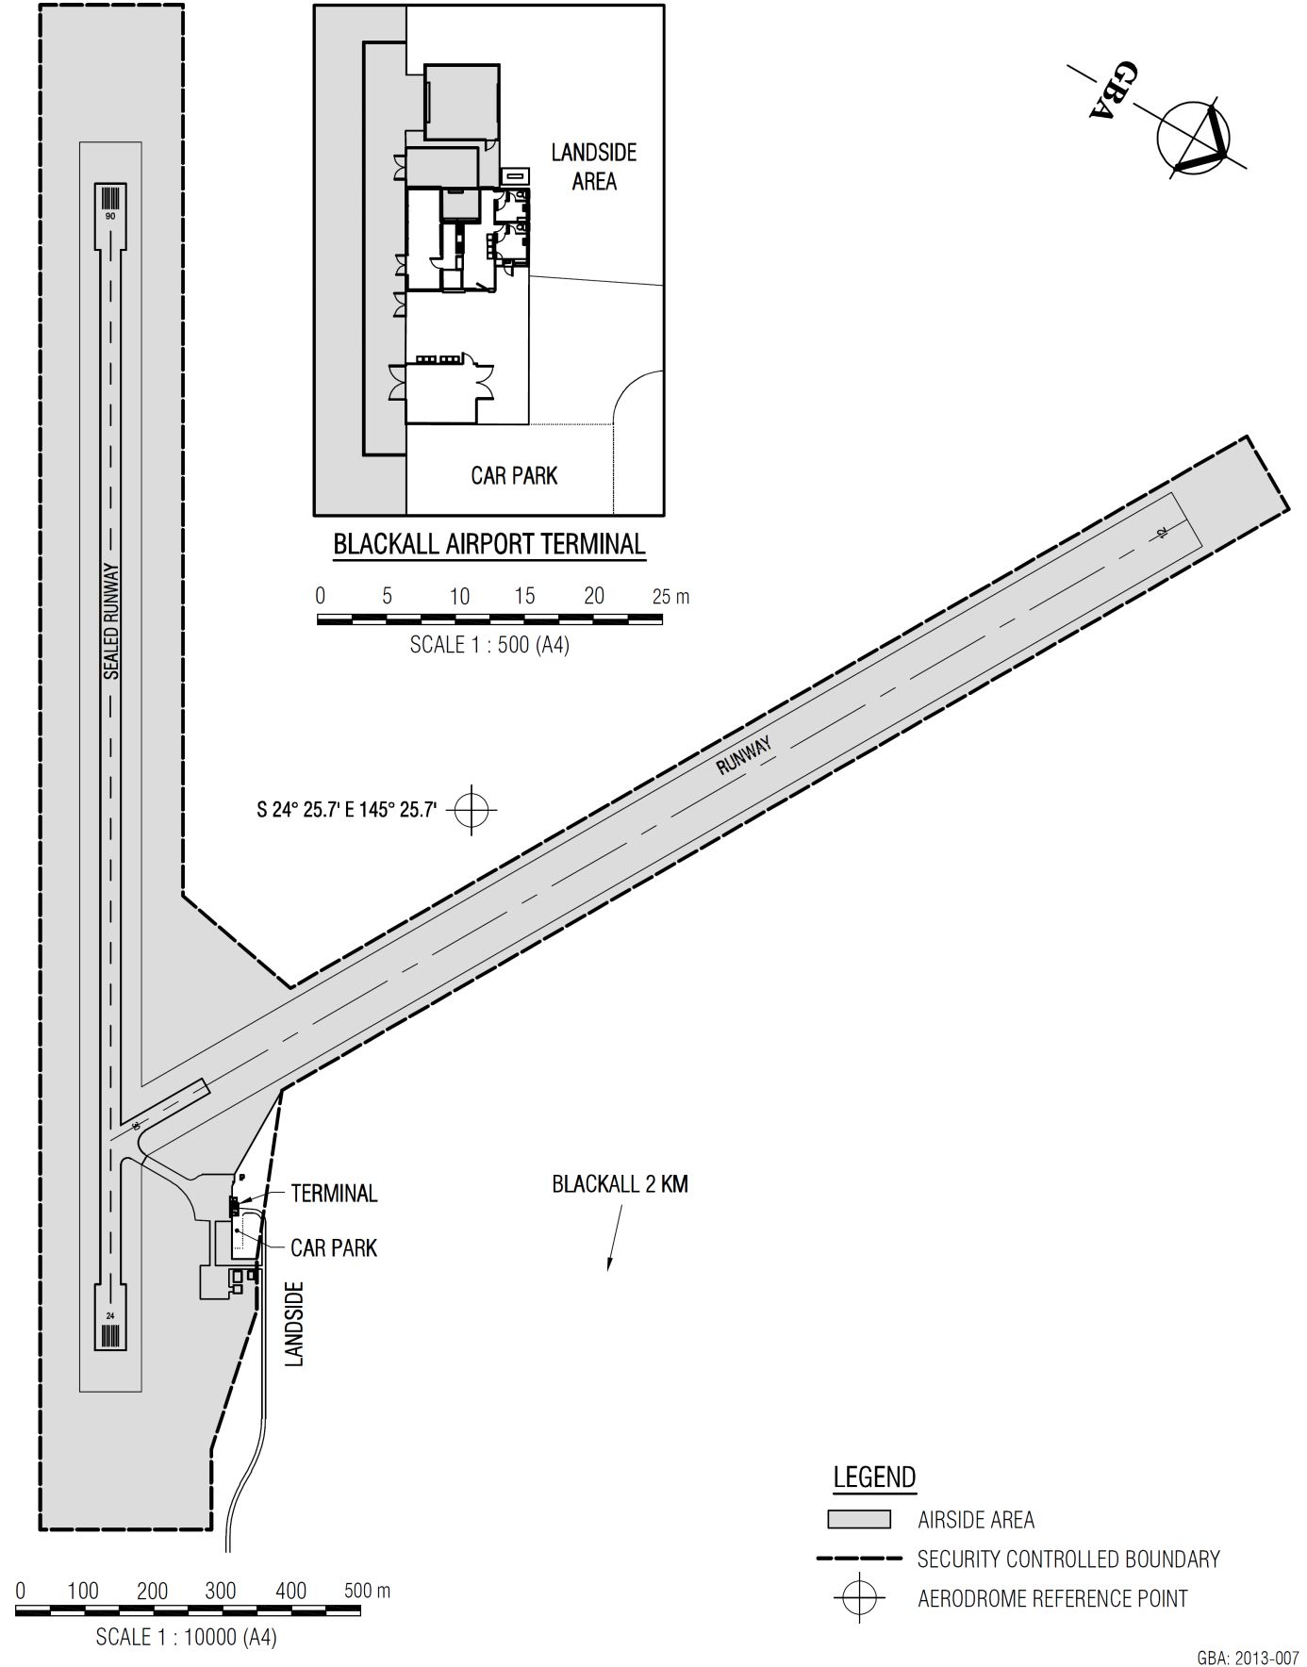
This map shows the boundaries of the security controlled airport and airside area for the purpose of the Aviation Transport Security Act 2004 and the Aviation Transport Security Regulations 2005 only. The map should not be used for air navigation purposes. Further information can be obtained from the Department of Infrastructure and Transport, Office of Transport Security (OTS), GPO Box 594, Canberra ACT 2601, or phone the Transport Security Coordination Centre on 1300 307 288.

