*Excise Tariff Act 1921*

**NOTICE OF SUBSTITUTED RATES OF EXCISE DUTY**

NOTICE No. 3 (2013)

I, JAMES O’HALLORAN, delegate of the Commissioner of Taxation, in accordance with subsection 6A(8) of the *Excise Tariff Act 1921* (the Tariff Act), give notice that, on and from 1 August 2013, the substituted rate of excise duty for goods classified to each item of the Schedule to the Tariff Act set out in Column 1 of the following table is the rate set out in Column 2 opposite each item.

In this notice, “item” means item and subitem.

**THE TABLE**

|  |  |
| --- | --- |
| Column 1 | Column 2 |
|  |  |
| Excise tariff item | Substituted rate of duty |
|  |  |
| 1.1 | $39.01 per litre of alcohol calculated on that alcohol content by which the percentage by volume of alcohol of the goods exceeds 1.15 |
| 1.2 | $7.79 per litre of alcohol calculated on that alcohol content by which the percentage by volume of alcohol of the goods exceeds 1.15 |
| 1.5 | $45.44 per litre of alcohol calculated on that alcohol content by which the percentage by volume of alcohol of the goods exceeds 1.15 |
| 1.6 | $24.44 per litre of alcohol calculated on that alcohol content by which the percentage by volume of alcohol of the goods exceeds 1.15 |
| 1.10 | $45.44 per litre of alcohol calculated on that alcohol content by which the percentage by volume of alcohol of the goods exceeds 1.15 |
| 1.11 | $31.99 per litre of alcohol calculated on that alcohol content by which the percentage by volume of alcohol of the goods exceeds 1.15 |
| 1.15 | $2.74 per litre of alcohol calculated on that alcohol content by which the percentage by volume of alcohol of the goods exceeds 1.15 |
| 1.16 | $3.17 per litre of alcohol calculated on that alcohol content by which the percentage by volume of alcohol of the goods exceeds 1.15 |
| 2 | $76.98 per litre of alcohol |
| 3.1 | $71.88 per litre of alcohol |
| 3.2 | $76.98 per litre of alcohol |
| 3.5  3.6  3.7  3.8 | Free  Free  Free  Free |
| 3.10 | $76.98 per litre of alcohol |
| 5.1 | $0.3571 per stick |
| 5.5 | $446.65 per kilogram of tobacco content |

Dated this Twenty-Fourth day of July 2013

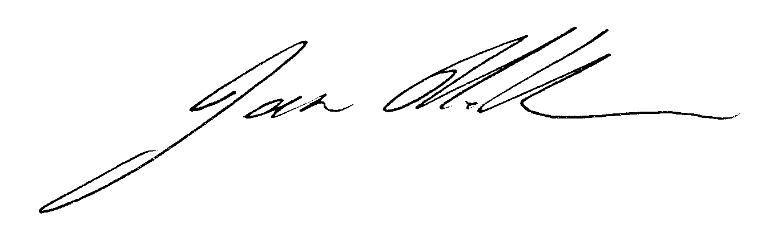

James O’Halloran

Delegate of the Commissioner of Taxation