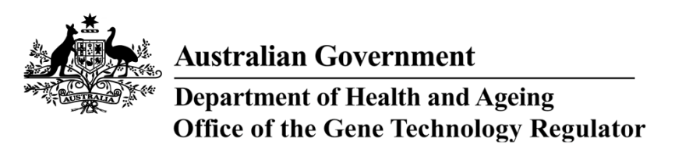
9 August 2013

invitation to comment on

genetically modified WHEAT field TRIAL
Australia’s gene technology regulatory system is designed to protect the health and safety of people and the environment by identifying risks posed by, or as a result of, gene technology and managing those risks.
The Gene Technology Regulator is currently assessing Licence Application DIR 122 from the Victorian Department of Primary Industries for a limited and controlled release of up to 40 lines of wheat that have been genetically modified for increased yield stability.
The primary purpose of the field trial is to evaluate the agronomic performance of the GM wheat under field conditions. The trial is proposed to take place over two growing seasons between November 2013 and December 2015. The GM wheat would be grown near Horsham, Victoria on a maximum area of 2 hectares per season. The GM wheat would not be permitted in human food or animal feed.
A consultation Risk Assessment and Risk Management Plan (RARMP) has been prepared, which concludes that the proposed release would pose negligible risk to human health and safety or to the environment. A range of draft licence conditions would limit the size, location and duration of the release, as well as restrict the spread and persistence of the GMOs and the introduced genetic material.
The Regulator welcomes written submissions in order to finalise the RARMP, which will then form the basis of a decision on whether or not to issue the licence. The consultation RARMP and related documents can be obtained from the OGTR website under ‘What’s New’ or by contacting the Office. Please quote application DIR 122 in any correspondence.
Submissions should be received by close of business on 20 September 2013.
Office of the Gene Technology Regulator, MDP 54, GPO BOX 9848 CANBERRA ACT 2601
Telephone: 1800 181 030 Facsimile: 02 6271 4202 E-mail: ogtr@health.gov.au
Website: http://www.ogtr.gov.au

