|  |
| --- |
| M01123 |
| DOIT-logo-inline.png |

***Maritime Transport and Offshore Facilities Security Act 2003***

**Notice of declaration of security regulated port – PORT of NORFOLK ISLAND**

I, **MICHAEL WILLIAM ROWE**, Regional Director, Transport Security Operations, Office of Transport Security, under subsection 13(1) of the *Maritime Transport and Offshore Facilities Security Act 2003* (the Act):

**REVOKE** the declaration of the security regulated port of Port of Norfolk Island published in the *Gazette (No. GN37, 20 September 2006)*; and

**DECLARE** that the area of the port of Port of Norfolk Island intended for use either wholly or partly in connection with the movement, loading, unloading, maintenance or provisioning of security regulated ships, the boundaries of which are shown on the attached map and descriptions, to be a security regulated port.

This Notice commences upon publication in the *Gazette*.

Date: 10 July 2013

Michael Rowe

Delegate of the Secretary of the

Department of Infrastructure and Transport

Note:

1. *Gazette* means the *Commonwealth of Australia Gazette*
2. This Notice remains in force until otherwise revoked in writing and upon subsequent publication in the *Gazette*.

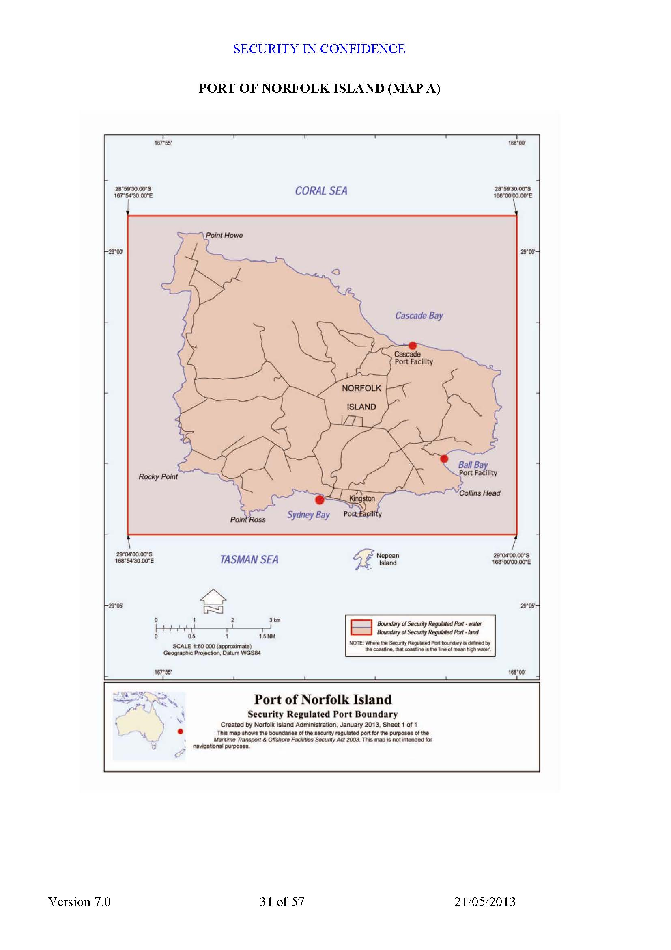

**SECURITY REGULATED PORT BOUNDARY DESCRIPTION**

**Description of Port of Norfolk Island**

State / Territory: Territory of Norfolk Island

Map Number: Geocat 70298

The Security Regulated Port of Norfolk Island is all that area of land and water contained within and bounded by a line commencing at a point in the South Pacific Ocean north-west of Norfolk Island at the point of intersection of the parallel of latitude 28° 59’ 30”south with the meridian of longitude 167° 54’ 30” east;

thence east along that parallel of latitude to its point of intersection with the meridian of longitude 168° 00’ 00”east;

thence south along that meridian to its point of intersection with the parallel of latitude 29° 04’ 00”south;

thence west along that parallel of latitude to its point of intersection with the meridian of longitude 167° 54’ 30” east;

thence north along that meridian of longitude to the point of commencement.

**Notes:**

1. All coordinates are in reference to the WGS 84 geodetic datum.

2. This description should be read in conjunction with the Security Regulated Port Boundary map. In the event of an inconsistency between the written description and the map, the former prevails.

3. This description and the associated maps have been compiled from information provided in February 2010 by the Office of Transport Security, Department of Infrastructure and Transport.