M01155
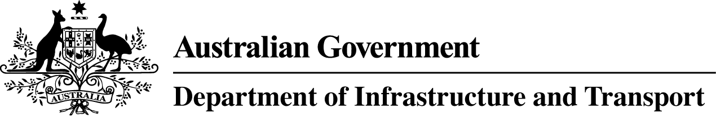

Maritime Transport and Offshore Facilities Security Regulations 2003

EXEMPTION FROM HOLDING, CARRYING AND DISPLAYING A MARITIME SECURITY IDENTIFICATION CARD (MSIC)

I, PAULINE MARGARET SULLIVAN, General Manager, Transport Security Operations, Office of Transport Security, under regulation 6.07M of the Maritime Transport and Offshore Facilities Security Regulations 2003 (the Regulations), GIVE all crew members on board regulated foreign off-take vessels (shuttle tankers), who are permitted to enter an offshore water-side zone for the purpose of offloading crude oil or condensates an exemption from holding, carrying or displaying an MSIC in accordance with the requirements set out in Part 6 of the Regulations .

This exemption operates from the date of this Notice and ceases on 30 June 2016.

This exemption is given on condition that:

  - The exemption applies to the operators of regulated foreign off-take vessels (or shuttle tankers) who are required to enter an offshore water-side zone to offload crude oil or condensates from an offshore oil or gas installation (including floating production, storage and off-take and floating storage and off-take facilities) only.
  - The exemption only applies if the operators of regulated foreign take-off vessels (or shuttle tankers) are authorised to enter an offshore water-side zone by the offshore facility operator concerned.
  - The exemption applies whenever offshore water-side zones are in force. That is when an offshore facility is at Maritime Security Levels 1, 2 and 3.
  - If crew members from a regulated foreign take-off vessel (or shuttle tanker) are required to board a regulated offshore facility for any purpose, they are to be escorted or continuously monitored by an MSIC holder if offshore facility zones are in force.

Date: 18 September 2013

Pauline Sullivan
Delegate of the Secretary of the
Department of Infrastructure and Transport

