 Government House

CANBERRA ACT 2600

#### 17 September 2013

## 

## ORDER OF AUSTRALIA

It is notified for general information that the Governor-General has cancelled the award of the Medal of the Order of Australia in the General Division made to:

**Ms Carin Lydia CLONDA**

### By Her Excellency’s Command

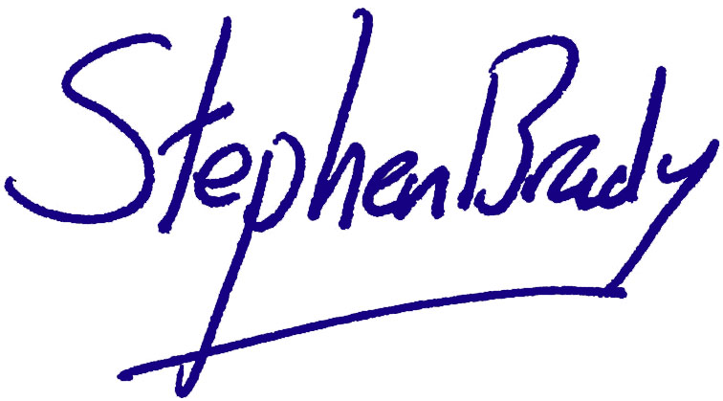

# Stephen Brady

#### Secretary of the Order of Australia