|  |
| --- |
| A05463 |
| http://communications/Logos/DoIRD_Strip.jpg |

***Aviation Transport Security Act 2004***

**NOTICE OF DECLARATION OF SECURITY CONTROLLED AIRPORT AND AIRSIDE AREA – NEWCASTLE AIRPORT**

I, **PAULINE MARGARET SULLIVAN**, General Manager, Transport Security Operations, Office of Transport Security:

**REVOKE**, under subsection 28(2) of the *Aviation Transport Security Act 2004* (the Act), Notice S28/2010 032 which declared Newcastle Airport as a security controlled airport as published in the *Gazette (No.GN 25, 30 June 2010)*;

**DECLARE**, under subsection 28(2) of the Act, that Newcastle Airport is a security controlled airport, the boundaries of Newcastle Airport are shown on the attached map which forms part of this notice; and

**ESTABLISH,** in accordance with section 29 of the Act, an airside area for Newcastle Airport being that area indicated as the airside area on the attached map.

This Notice commences upon publication in the *Gazette*.

Date: 25 October 2013

Pauline Sullivan

Delegate of the Secretary of the

Department of Infrastructure and Regional Development

Note:

1. *Gazette* means the *Commonwealth of Australia Gazette*
2. This Notice remains in force until otherwise revoked in writing and upon subsequent publication in the *Gazette*.

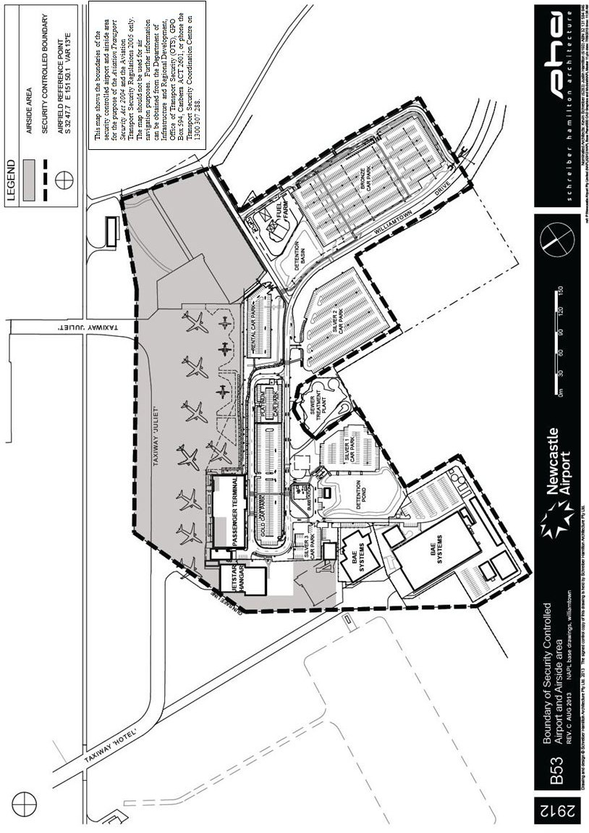

This map shows the boundaries of the security controlled airport and airside area for the purpose of the *Aviation Transport Security Act 2004* and the Aviation Transport Security Regulations 2005 only. The map should not be used for air navigation purposes. Further information can be obtained from the Department of Infrastructure and Regional Development, Office of Transport Security (OTS), GPO Box 594, Canberra ACT 2601, or phone the Transport Security Coordination Centre on 1300 307 288.