

Government House

CANBERRA ACT 2600

#### 13 November 2013

## 

## DISTINGUISHED SERVICE DECORATIONS

It is notified for general information that the Governor-General cancelled the award of the Commendation for Distinguished Service made to:

**Mr (formally Major) Robin Paul TURNER**

### By Her Excellency’s Command

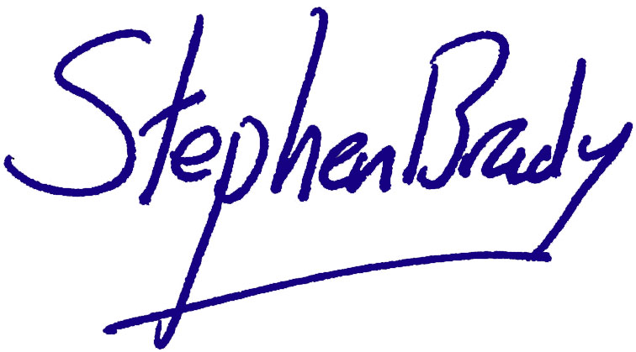

# Stephen Brady CVO

#### Official Secretary to the Governor-General