

*Environment Protection and Biodiversity Conservation Regulations 2000*

Subregulation 12.56(2)

**DETERMINATION PROHIBITING USE OF RECREATIONAL VESSELS WITH FISHING GEAR IN USE**

**MERMAID REEF COMMONWEALTH MARINE RESERVE**

I, CHARLTON CLARK, Assistant Secretary, Commonwealth Marine Reserves Branch, Parks Australia Division, Department of the Environment, delegate of the power of the Director of National Parks under subregulation 12.56(2) of the *Environment Protection and Biodiversity Conservation Regulations 2000,* HEREBY DETERMINE that the area of Mermaid Reef Commonwealth Marine Reserve, being the area of water specified in the Schedule hereto, is an area of water where use of the following class of vessels:

* vessels that are being used in connection with recreational fishing and have fishing gear on board and in use,

is prohibited at all times.

In this determination:

(a) recreational fishing means fishing other than commercial fishing; and

(b) fishing gear means equipment designed to be used to attract or take fish or other aquatic animals.

Dated this 14th day of December 2013

**SIGNED**

..............................................

Charlton Clark

**SCHEDULE**

**The area of Mermaid Reef Commonwealth Marine Reserve:**

All of that area within the Indian Ocean contained within and bounded as follows*:

1. commencing at the point of latitude 16 degrees 58 minutes south, longitude 119 degrees 32 minutes east;
2. then east along the parallel of latitude 16 degrees 58 minutes south to its intersection with the meridian of longitude 119 degrees 43 minutes east;
3. then south along the meridian of longitude 119 degrees 43 minutes east to its intersection with the parallel of latitude 17 degrees 13 minutes south;
4. then west along the parallel of latitude 17 degrees 13 minutes south to its intersection with the meridian of longitude 119 degrees 32 minutes east; and
5. then north along the meridian of longitude 119 degrees 32 minutes east to the point of commencement.

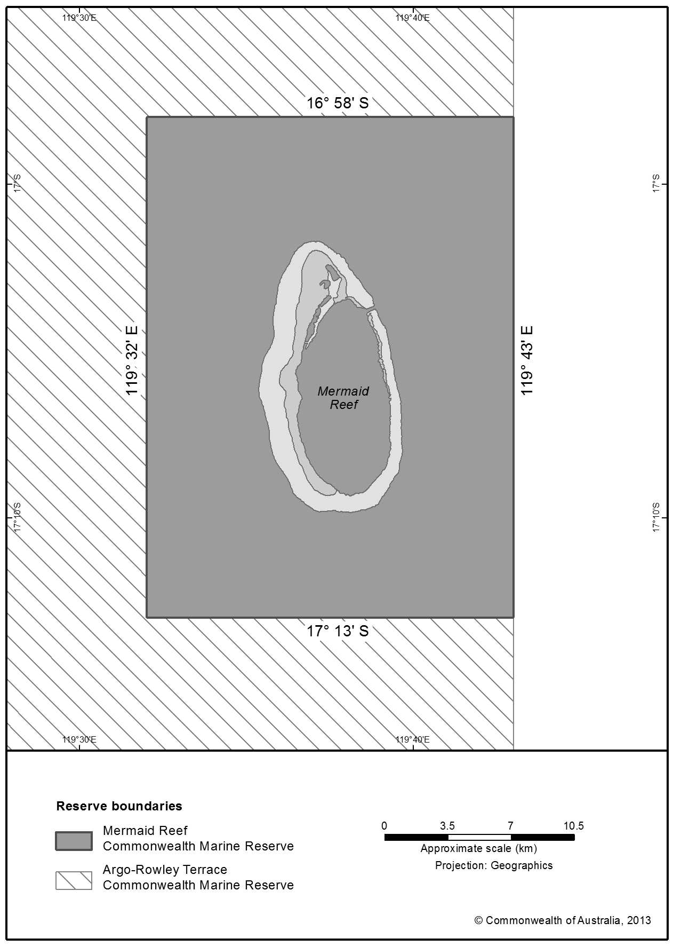

* All geographic coordinates are expressed in terms of the Geocentric Datum of Australia 1994 (GDA94) as described in the *Commonwealth of Australia Gazette* GN35 of 6 September 1995.