

**Government House**

**CANBERRA ACT 2600**

##### 18 February 2014

**It is notified for general information that Her Majesty The Queen has approved the award of the *Victoria Cross for Australia* to:**

**Corporal Cameron Stewart BAIRD MG (deceased)**

For the most conspicuous acts of valour, extreme devotion to duty and ultimate self-sacrifice at Ghawchak village, Uruzgan Province, Afghanistan as a Commando Team Commander in Special Operations Task Group on Operation SLIPPER.

# By Her Excellency’s Command

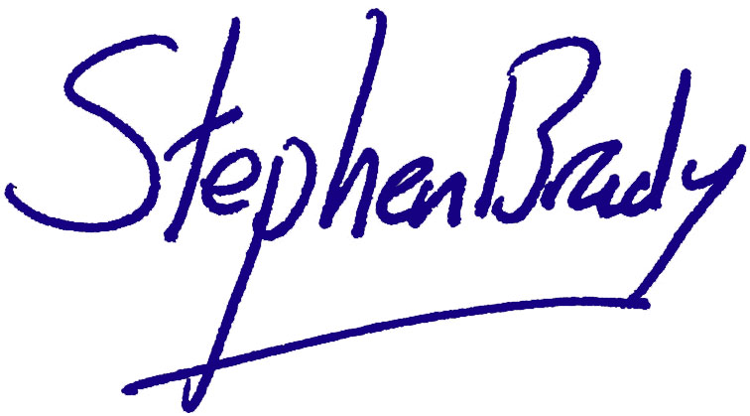

# Stephen Brady CVO

Official Secretary to the Governor-General

*Australian Army*

**Corporal Cameron Stewart BAIRD MG (deceased)**

For the most conspicuous acts of valour, extreme devotion to duty and ultimate self-sacrifice at Ghawchak village, Uruzgan Province, Afghanistan as a Commando Team Commander in Special Operations Task Group on Operation SLIPPER.

On 22 June 2013, Corporal Baird displayed conspicuous valour and ultimate self-sacrifice in close combat with a determined enemy. With complete disregard for his own safety, he repeatedly drew enemy fire to himself in order to allow his team to manoeuvre, and charged prepared enemy positions in the face of heavy fire. His efforts enabled the enemy to be neutralised and kept his team safe, but ultimately cost him his life. His actions were of the highest order and in keeping with the finest traditions of the Australian Army and the Australian Defence Force.