|  |
| --- |
| M01286 |
|  |

***Maritime Transport and Offshore Facilities Security Act 2003***

**Notice of declaration of security regulated port – PORT OF BURNIE**

I, **COLIN JAMES SIEVERS**, Acting Regional Director, Transport Security Operations, Office of Transport Security, under subsection 13(1) of the *Maritime Transport and Offshore Facilities Security Act 2003* (the Act):

**REVOKE** the declaration of the security regulated Port of Burnie published in the *Gazette (No. GN 22, 2 June 2004)* on Line no. 12 of Column A (the port) and shown on the map identified as ‘12. Port of Burnie’ on page 1440; and

**DECLARE** that the area of the port of Burnie intended for use either wholly or partly in connection with the movement, loading, unloading, maintenance or provisioning of security regulated ships, the boundaries of which are shown on the attached map, to be a security regulated port.

This Notice commences upon publication in the *Gazette*.

Date: 28 February 2014

Colin Sievers

Delegate of the Secretary of the

Department of Infrastructure and Transport

Note:

1. *Gazette* means the *Commonwealth of Australia Gazette*
2. This Notice remains in force until otherwise revoked in writing and upon subsequent publication in the *Gazette*.

RAT339-01

**Port of Burnie Security Regulated Port Map**

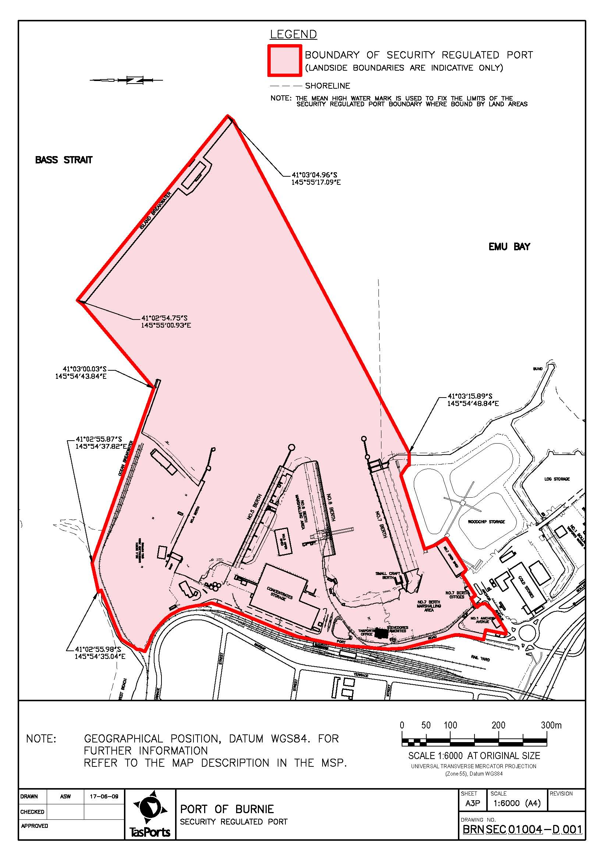

This map shows the boundaries of the security regulated port for the purposes of the *Maritime Transport & Offshore Facilities Security Act 2003*. This map is not intended for navigational purposes. Further information can be obtained from the Department of Infrastructure, and Transport, Office of Transport Security (OTS), GPO Box 594, Canberra ACT 2601, or phone the Transport Security Coordination Centre on 1300 307 288.