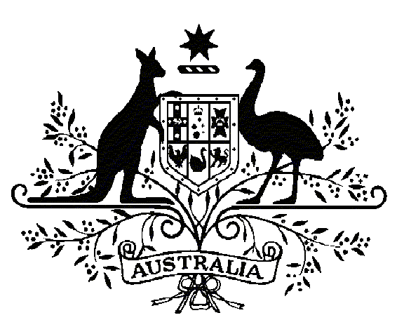
Specialist Medical Review Council

Declaration
Section 196W
Veterans’ Entitlements Act 1986

Re: Statements of Principles
Nos. 89 & 90 of 2011 (Diabetes Mellitus)
Request for Review Declaration No. 24

In relation to the Repatriation Medical Authority (the RMA) Statements of Principles Nos. 89 and 90 of 2011 concerning diabetes mellitus, made under subsections 196B (2) and (3) of the Veterans' Entitlements Act 1986 (the VEA), the Specialist Medical Review Council (the Council) under subsection 196W of the VEA:
DECLARES that it is of the view that the sound medical-scientific evidence on which the RMA could have relied to amend either of the Statements of Principles is insufficient to include a factor or factors for
having been on board a vessel and having been exposed to dioxin diluted in water supplied on that vessel, including but not limited to consuming potable water, when the supply had been produced by evaporative distillation of estuarine Vietnamese waters.

 | Charles Guest
 | Convener
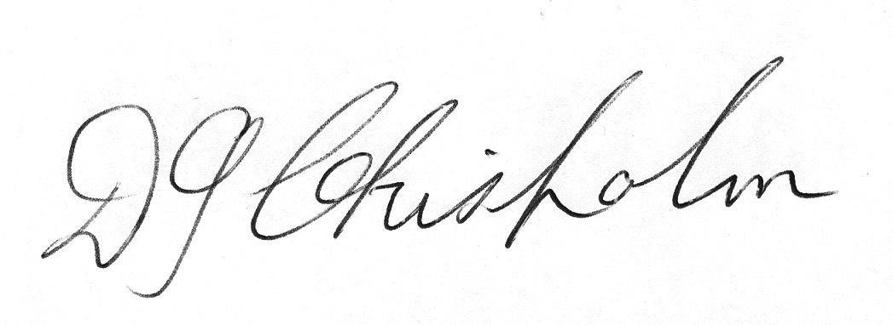 |  |  |  | 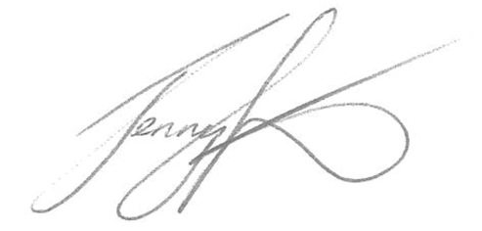 | 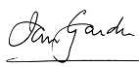
Don Chisholm |  | John Funder |  | Jenny Gunton | Ian Gardner
Councillor |  | Councillor |  | Councillor | Councillor

The Common Seal of the )
Specialist Medical Review )
Council was affixed by )
authority of the Council in )
the presence of: )

Jan Bowman
Registrar, SMRC

Dated this TWELFTH day of MAY 2014

The Council’s Reasons for Decision in relation to this Declaration can be obtained from its website at www.smrc.gov.au or on request by writing to the Specialist Medical Review Council Secretariat, PO Box 895, Woden ACT 2606 or by telephoning (07) 3223 8420.

