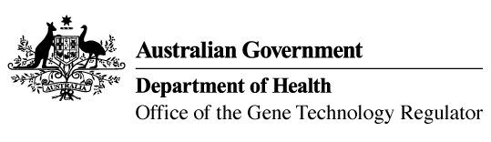
1 July 2014

Invitation to comment on genetically modified (GM)
wheat and barley field trial
Australia’s gene technology regulatory system is designed to protect the health and safety of people and the environment by identifying risks posed by, or as a result of, gene technology and managing those risks.
The Gene Technology Regulator is currently assessing Licence Application DIR 128 from The University of Adelaide for a limited and controlled release of wheat and barley that have been genetically modified for abiotic stress tolerance or micronutrient uptake.
The primary purpose of the field trial is to assess the yield potential of the GM plants. The trial is proposed to take place between August 2014 and December 2019 at five trial sites, two in South Australia and three in Western Australia. The collective maximum area for the trial is 2.5 hectares per year. The GM wheat and barley would not be used in human food or animal feed.
A consultation Risk Assessment and Risk Management Plan (RARMP) has been prepared, which concludes that the proposed release would pose negligible risk to human health and safety or to the environment. A range of draft licence conditions would limit the size, locations and duration of the release, as well as restrict the spread and persistence of the GMOs and the introduced genetic material.
The Regulator welcomes written submissions in order to finalise the RARMP, which will then form the basis of a decision on whether or not to issue the licence. The consultation RARMP and related documents can be obtained from the DIR 128 page of the OGTR website or requested via the contacts detailed below.
Submissions should be received by close of business on 31 July 2014.
Office of the Gene Technology Regulator, MDP 54, GPO BOX 9848 CANBERRA ACT 2601
Telephone: 1800 181 030 Facsimile: 02 6271 4202 E-mail: ogtr@health.gov.au
Website: http://www.ogtr.gov.au

