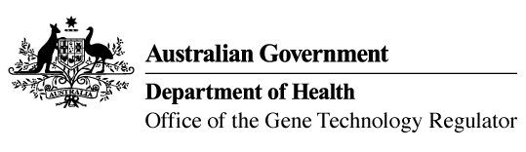

24 July 2014

**Invitation to comment on commercial release   
of genetically modified (GM) canola**

Australia’s gene technology regulatory system is designed to protect the health and safety of people and the environment by identifying risks posed by, or as a result of, gene technology and managing those risks.

The Gene Technology Regulator is currently assessing licence application DIR 127 from Monsanto Australia Ltd for a commercial release of MON 88302 canola, which has been genetically modified for tolerance to the herbicide glyphosate.

Subject to any State government restrictions imposed for marketing reasons, the proposed commercial release of this GM canola would be Australia wide. Products from the GM canola would be used in the same way as those from non-GM and other commercially approved GM canola.

A consultation Risk Assessment and Risk Management Plan (RARMP) has been prepared, which concludes that the proposed release would pose negligible risk to human health and safety or to the environment. Draft licence conditions are proposed to ensure there is ongoing oversight of the release.

The Regulator welcomes written submissions in order to finalise the RARMP, which will then inform the decision on whether or not to issue a licence. The consultation RARMP and related documents can be obtained from the OGTR website under ‘[What’s New](http://www.ogtr.gov.au/internet/ogtr/publishing.nsf/Content/new-index-1)’ or by contacting the Office. Please quote application DIR 127 in any correspondence.

Submissions should be received by close of business on **18 September 2014**.

**Office of the Gene Technology Regulator, MDP 54, GPO BOX 9848 CANBERRA ACT 2601**

**Telephone: 1800 181 030 Facsimile: 02 6271 4202 E-mail:** [**ogtr@health.gov.au**](mailto:ogtr@health.gov.au)

**Website: http://www.ogtr.gov.au**