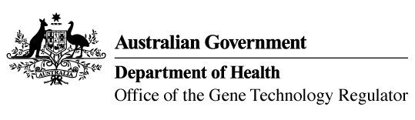
9 December 2014

Invitation to comment on genetically modified (GM) wheat field trial
Australia’s gene technology regulatory system is designed to protect the health and safety of people and the environment by identifying risks posed by, or as a result of, gene technology and managing those risks.
The Gene Technology Regulator is currently assessing licence application DIR 130 from Murdoch University for a limited and controlled release of wheat that has been genetically modified for improved grain quality.
The primary purpose of the field trial is to assess whether the introduction and expression of two genes will increase the strength of dough. The trial is proposed to take place between May 2015 and December 2017 at one trial site in Western Australia. The maximum area for the trial is 0.06 hectares per year. The GM wheat would not be used in human food or animal feed.
A consultation Risk Assessment and Risk Management Plan (RARMP) has been prepared, which concludes that the proposed release would pose negligible risk to human health and safety or to the environment. A range of draft licence conditions would limit the size, location and duration of the release, as well as restrict the spread and persistence of the GMOs and the introduced genetic material.
The Regulator welcomes written submissions in order to finalise the RARMP, which will then form the basis of a decision on whether or not to issue the licence. The consultation RARMP and related documents can be obtained from the OGTR website under ‘What’s New’ or by contacting the Office. Please quote application DIR 130 in any correspondence.
Submissions should be received by close of business on 27 January 2015.
Office of the Gene Technology Regulator, MDP 54, GPO BOX 9848 CANBERRA ACT 2601
Telephone: 1800 181 030 Facsimile: 02 6271 4202 E-mail: ogtr@health.gov.au
Website: http://www.ogtr.gov.au

