Description: Commonwealth Coat of Arms

# Ministerial Direction (Commonwealth Director of Public Prosecutions)

## Director of Public Prosecutions Act 1983

I, George Brandis QC, Attorney-General of Australia, having consulted the Director of Public Prosecutions (‘the Director’), give the following direction under subsection 8(1) of the *Director of Public Prosecutions Act 1983*.

The Director must not proceed with a prosecution of a person for alleged contravention of the following sections without the written consent of the Attorney-General:

* 1. section 35P of the *Australian Security Intelligence Organisation Act 1979*
  2. section 15HK of the *Crimes Act 1914*
  3. section 15HL of the *Crimes Act 1914;* or
  4. section 3ZZHA of the *Crimes Act 1914*

where the person is a journalist and the facts constituting the alleged offence relate to the work of the person in a professional capacity as a journalist.

Dated 30 October 2014

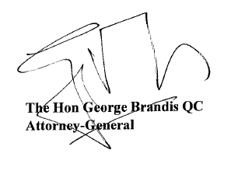

Parliament House Canberra ACT 2600 • Telephone: (02) 6277 7300 Facsimile: (02) 6273 4102