 Government House

CANBERRA ACT 2600

#### 12 December 2014

## 

## ORDER OF AUSTRALIA

It is notified for general information that the Governor-General has cancelled the award of the Medal of the Order of Australia in the General Division made to:

**Mr Edward Moses Obeid**

### By His Excellency’s Command

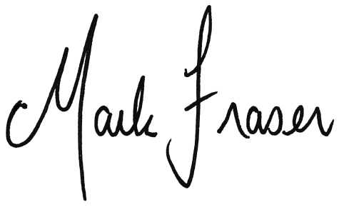

# Mark Fraser LVO OAM

#### Secretary of the Order of Australia