 Government House

CANBERRA ACT 2600

#### 12 December 2014

## 

## ORDER OF AUSTRALIA

It is notified for general information that the Governor-General has:

Terminated the appointment of Member of the Order of Australia in the General Division, made to

**Mr Colin Gregory Ryan**

and

Cancelled the award of the Medal of the Order of Australia in the General Division, made to

**Mr John Wallace Meyers**

### By His Excellency’s Command

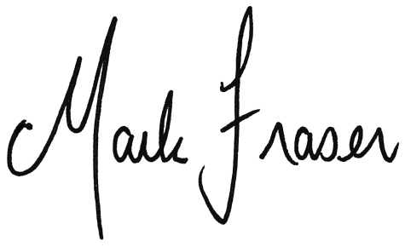

# Mark Fraser LVO OAM

#### Secretary of the Order of Australia