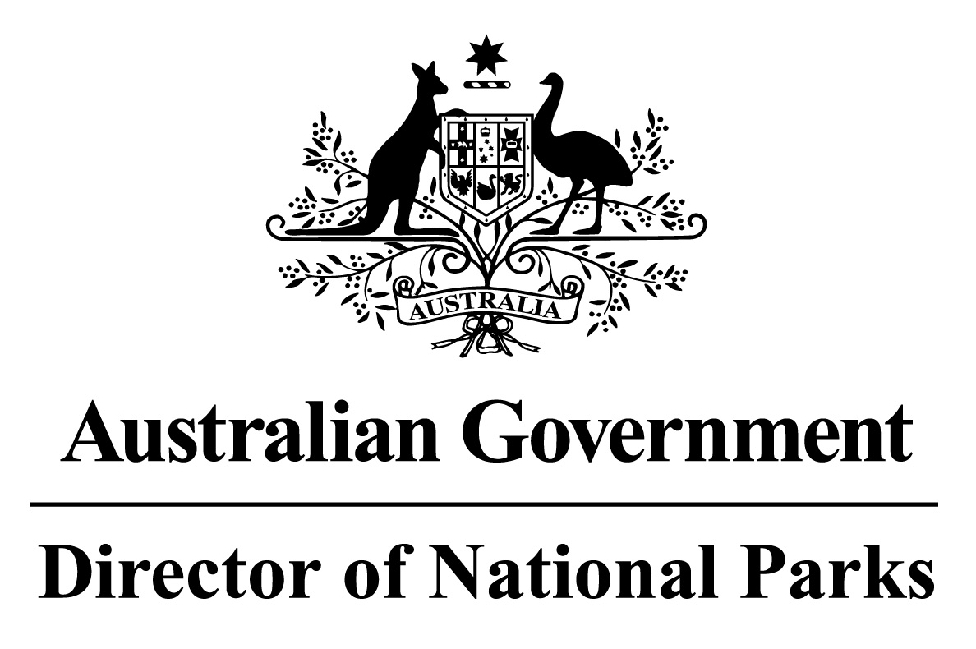

Environment Protection and Biodiversity Conservation Regulations 2000

Sub-regulation 12.56 (2)

SOUTH EAST COMMONWEALTH MARINE RESERVES NETWORK

DETERMINATION PROHIBITING USE OF VESSELS ENGAGED IN CAGE TOWING

I, BARBARA MUSSO, Assistant Secretary, Commonwealth Marine Reserves Branch, Parks Australia Division, Department of the Environment, delegate of the power of the Director of National Parks under sub-regulation 12.56(2) of the Environment Protection and Biodiversity Conservation Regulations 2000 and, in accordance with Section 5.3.1 of the South-east Commonwealth Marine Reserve Network Management Plan, HEREBY DETERMINE that all Sanctuary (IUCN Ia) and Marine National Park (IUCN II) network management zones in each of the Commonwealth reserves in the Network, being the reserves listed in the Schedule to this determination, are areas of water where the use of vessels engaged in cage towing is prohibited unless done in accordance with a permit or approval issued by the Director.

In this determination:

cage towing means a vessel towing a cage that is suitable for caging fish.

network management zone means a network management zone prescribed by the South-east Commonwealth Marine Reserve Network Management Plan.

Dated this 7 day of January 2015

SIGNED

....................................

Barbara Musso
SCHEDULE

SOUTH EAST COMMONWEALTH MARINE RESERVES NETWORK

Apollo Commonwealth Marine Reserve
Beagle Commonwealth Marine Reserve
Boags Commonwealth Marine Reserve
East Gippsland Commonwealth Marine Reserve
Flinders Commonwealth Marine Reserve
Franklin Commonwealth Marine Reserve
Freycinet Commonwealth Marine Reserve
Huon Commonwealth Marine Reserve
Macquarie Island Commonwealth Marine Reserve
Murray Commonwealth Marine Reserve
Nelson Commonwealth Marine Reserve
South Tasman Rise Commonwealth Marine Reserve
Tasman Fracture Commonwealth Marine Reserve
Zeehan Commonwealth Marine Reserve

