Government House
CANBERRA ACT 2600
12 February 2015

It is notified for general information that the Governor-General has approved the following Gallantry award for A Far East Prisoner of War, World War II:

In recognition of bravery and courage as an Australian prisoner of war during World War II who died while escaping from Japanese forces or who were executed following recapture.

COMMENDATION FOR GALLANTRY

For acts of gallantry in action while a prisoner of war

AUSTRALIAN ARMY

Sergeant Clifford Edmond DANAHER

By His Excellency’s Command

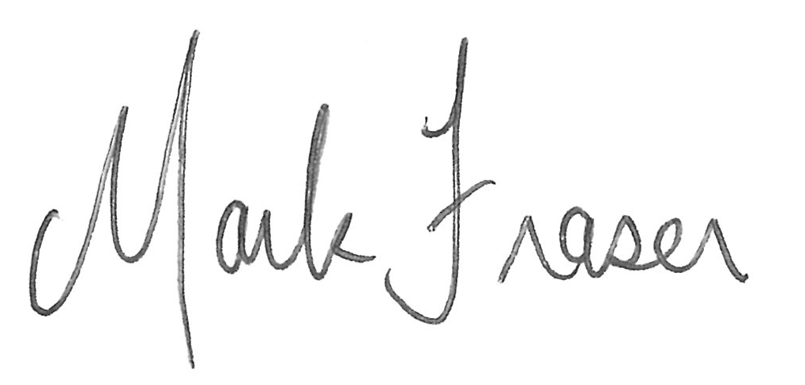
Mark Fraser LVO OAM
Official Secretary to the Governor-General

