 Government House

CANBERRA ACT 2600

#### 27 March 2015

## 

## ORDER OF AUSTRALIA

It is notified for general information that the Governor-General has terminated the appointment of Officer of the Order of Australia in the Military Division, made to:

**Mr Geoffrey Francis Smith**

### By His Excellency’s Command

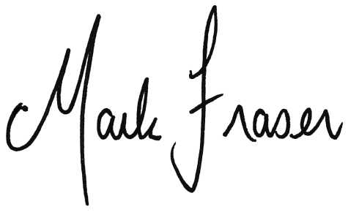

# Mark Fraser LVO OAM

#### Secretary of the Order of Australia