**HEAVY VEHICLE NATIONAL LAW**

**NOTICE OF RESPONSIBLE MINISTERS APPROVAL 2015 (No. 1)**

I, Sal PetrocCitto, Chief Executive Officer of the National Heavy Vehicle Regulator, publish this notice of the approval given by the responsible Ministers for the purposes of Chapter 8 of the National Law, pursuant to section 654(1)(c) of the Heavy Vehicle National Law as applied in participating jurisdictions.

The approval of this notice relates to the following class of auditors, and revokes the previous approval given for previous classes of auditors—

**Approved Class of Auditors**

1. For the purposes of s 654(1)(c) of the Heavy Vehicle National Law, ‘class of auditors’ means an auditor who is registered with the NHVR.
2. A register of auditors is maintained by the NHVR and published on the NHVR website.

**Transitional Arrangements**

A person who is currently certified by Exemplar Global (previously known as RABQSA) as a Heavy Vehicle Accreditation auditor continues to be recognised as an auditor with regard to any heavy vehicle accreditation under the National Law for which they are certified until 30 June 2016.

Dated: 10 June 2015

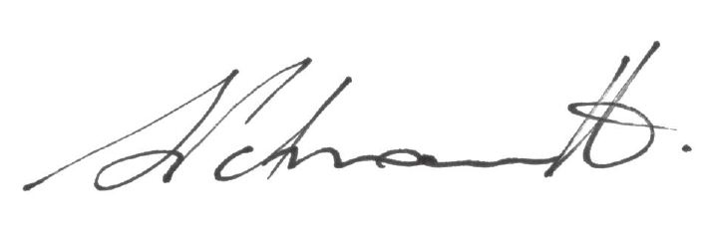

Salvatore Petroccitto

**Chief Executive Officer**

National Heavy Vehicle Regulator