DIVISION 126, PRIVATE HEALTH INSURANCE ACT 2007

NOTICE OF CANCELLATION OF THE REGISTRATION OF A PRIVATE HEALTH INSURER

The Private Health Insurance Administration Council has exercised its power under Section

126-45 of the *Private Health Insurance Act 2007* to cancel the registration of the following private health insurer from midnight 30 June 2015:

• HealthGuard Health Benefits Fund Ltd (ABN 26 054 321 274)

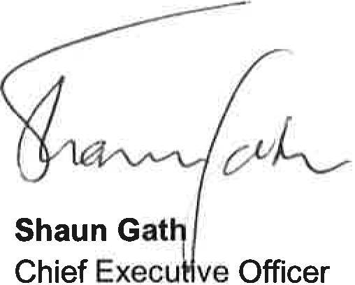

Private Health Insurance Administration Council

19 May 2015