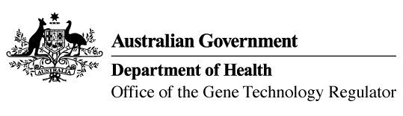
11 December 2015

Invitation to comment on commercial release
of genetically modified (GM) canola
Australia’s gene technology regulatory system is designed to protect the health and safety of people and the environment by identifying risks posed by, or as a result of, gene technology and managing those risks.
The Gene Technology Regulator is currently assessing licence application DIR 139 from Pioneer Hi-Bred Australia Pty Ltd for a commercial release of Optimum™ GLY Canola. This canola variety has been genetically modified for tolerance to the herbicide glyphosate.
Subject to any State government restrictions imposed for marketing reasons, the proposed commercial release of the GM canola would be Australia-wide. The GM canola and its products would enter general commerce, including use in human food and animal feed.
A consultation Risk Assessment and Risk Management Plan (RARMP) has been prepared, which concludes that the proposed release would pose negligible risk to human health and safety or to the environment. Draft licence conditions are proposed to ensure there is ongoing oversight of the release.
The Regulator welcomes written submissions in order to finalise the RARMP, which will then inform the decision on whether or not to issue a licence. The consultation RARMP and related documents can be obtained from the OGTR website under ‘What’s New’ or by contacting the Office. Please quote application number DIR 139 in any correspondence.
Submissions should be received by close of business on 11 February 2016.
Office of the Gene Technology Regulator, MDP 54, GPO Box 9848 Canberra ACT 2601
Telephone: 1800 181 030 Facsimile: 02 6271 4202 E-mail: ogtr@health.gov.au
Website: http://www.ogtr.gov.au

