NORFOLK ISLAND

BRANDS AND MARKS REGULATIONS

[Consolidated as at 28 February 2013
on the authority of the Administrator
and in accordance with
the Enactments Reprinting Act 1980]
________

TABLE OF PROVISIONS

PART 1 - PRELIMINARY

1. Citation
2. Forms
3. Application for registration
4. Application for transfer
5. Certificate of registration
6. Brands to comply with certain conditions
7. Cancellation of registration
8. Fees
9. Order of brands of cattle and horses
10. Branding and marking of sheep
11. Penalties

Schedule 1
Schedule 2

NORFOLK ISLAND

Brands and Marks Regulations

Citation
- These regulations may be cited as the Brands and Marks Regulations.

Forms
2. Any reference in these regulations to a form shall be read as a reference to a form in Schedule 1 to these regulations.

Application for registration
3. (1) Application for the registration of a brand or mark shall be in accordance with Form 1.
(2) Application by the legal personal representative of a deceased proprietor for the transfer of a brand or mark shall be in accordance with Form 2.

Application for transfer
4. Application for the transfer of a brand or mark shall be in accordance with Form 3.

Certificate of registration
5. Upon the registration of any brand or mark or the transfer of any brand or mark, a certificate of registration in accordance with Form 4 shall be sent to the proprietor thereof.

Brands to comply with certain conditions
6. A brand shall not be registered unless it complies with the following conditions ⎯
(a) where the brand, wholly or in part, consists of a letter or letters, conjoined letters or a numeral or numerals, or any combination of letters, conjoined letters and numerals, each of such letters, conjoined letters or numerals shall not be less than one and a half inches nor more than three inches in height measured in their normal position and shall not be less than half an inch apart from any letter, conjoined letters or numeral forming part of that brand.
(b) where the brand, wholly or in part, consists of a sign or character, such sign or character shall not be less than one and a half inches nor more than three inches in its greatest width or length, and shall not be less than half an inch apart from any letter, conjoined letters, numeral, sign or character forming part of that brand.

Cancellation of registration
7. Registration of a brand or mark may be cancelled by the Registrar upon the production of a certificate of the death of the proprietor thereof or other satisfactory evidence showing that such death occurred not less than six months previously if ⎯
(a) an application under subregulation (2) of regulation 3 of these regulations has not been received by the Registrar; and
(b) notice of such intended cancellation has been posted to the legal personal representative of the deceased proprietor at his last known address and objection to such cancellation has not been received within two months from the date of posting of such notice.

Fees
8. The fee for the registration of any brand or mark or for the transfer of any brand or mark shall be $1.

Order of brands of cattle and horses
- Any cattle and horses not already branded shall be branded in the following order and position ⎯
Cattle ⎯
1st brand ⎯ on the left rump.
2nd brand – on the right rump.
Horses ⎯
1st brand ⎯ on the left shoulder.
2nd brand – on the right shoulder.
Branding and marking of sheep
10. (1) A pitch, tar or paint brand shall be on the rump of the sheep.
(2) An ear-mark shall be made or marked with an ear-plier, the cutters of which shall be of the size and shape described in Schedule 2 to these regulations.

(3) The ear-mark shall in every case be marked on the left ear of male sheep and the right ear of female sheep.
Penalties
11. Any person who contravenes or fails to comply with any provision of these regulations or makes any false statement or declaration in any form presented to the Registrar shall be guilty of an offence and shall be liable, upon conviction, to a fine not exceeding five pounds.
_____________________

SCHEDULE 1
The Territory of Norfolk Island
Brands and Marks Act 1949
FORM 1
APPLICATION FOR REGISTRATION OF A BRAND OR MARK
To the Registrar of Brands and Marks,
Norfolk Island
I, ………………………………… , of ……………………………………………………. ,
(Name in full and address)

make application for the registration of the brand or mark * shown hereunder.
I have not had a registered brand or mark* in the Territory.
Signature
Date
Brand or mark applied for | Brand or mark allotted or modification suggested  (to be filled in by Registrar)
* Strike out whichever is inapplicable.
__________________

The Territory of Norfolk Island
Brands and Marks Act 1949
FORM 2
APPLICATION BY LEGAL PERSONAL REPRESENTATIVE FOR TRANSFER OF A BRAND OR MARK
I, ………………………………… , of ……………………………………………..…….. ,
(Name in full and address)
being the legal personal representative of the late ………………………………………….
(Name in full and address)
who was the registered proprietor of the brand or mark * shown hereunder, and who died on the …………… day of ………………………. 20 …… , apply for transfer of such brand or mark.*
Signature
Date
Registered brand or mark | No. of original certificate of registration | Decision of Registrar
* Strike out whichever is inapplicable.
__________________
The Territory of Norfolk Island
Brands and Marks Act 1949
FORM 3
APPLICATION FOR TRANSFER OF BRAND OR MARK
To the Registrar of Brands and Marks,
Norfolk Island

I, ………………………………… , being the registered proprietor of the brand or mark * shown hereunder, desire to transfer the same to ………………………………………….. of ……………………………………
Subject to the granting of this application, I admit I am not further entitled to the use of this brand or mark * .
Registered Proprietor
Date
I agree to accept the transfer of the brand or mark * shown hereunder.
Transferee
Date
Brand or mark * to be transferred
* Strike out whichever is inapplicable.
__________________

The Territory of Norfolk Island
Brands and Marks Act 1949
FORM 4
CERTIFICATE OF REGISTRATION
Application No.
This is to certify that …………………………………………..
of ………………..……….……………………………………
has this day been registered as the proprietor of the brand or mark * shown in the margin hereof for use on stock in accordance with the provisions of the Brands and Marks Act 1949 and the regulations thereunder.
Registrar of Brands and Marks
Date
* Strike out whichever is inapplicable
__________________

SCHEDULE 2
NAME, SHAPE AND SIZE OF SHEEP EAR-MARKS

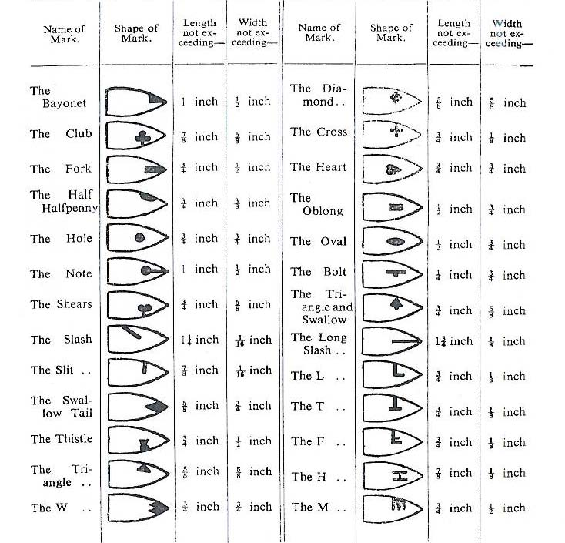

_______________________________________________________________________

NOTES
The Regulations as shown in this consolidation comprises Brands and Marks Regulations, No. 2 of 1949 and amendments as indicated in the Tables below.
Enactment | Number and year | Date of commencement | Application saving or transitional provision
Brands and Marks Regulations | 2, 1949 | 7.12.1949
Brands and Marks Regulations (Amending) | 1, 1954 | 22.3.1954
Brands and Marks Regulations (Amending) | 3, 1976 | 16.12.1976

Table of Amendments

ad = added or inserted | am = amended |  |  | rep = repealed | rs = repealed and substituted
Provisions affected |  | How affected
8 |  | am | 1, 1954
8 |  | am | 3, 1976

© Norfolk Island Government 2013
The Copyright Act 1968 of the Commonwealth of Australia permits certain reproduction and publication of this legislation. For reproduction or publication beyond that permitted by the Act, written permission must be sought from the Legislative Counsel, Administration of Norfolk Island, Norfolk Island, South Pacific 2899.

