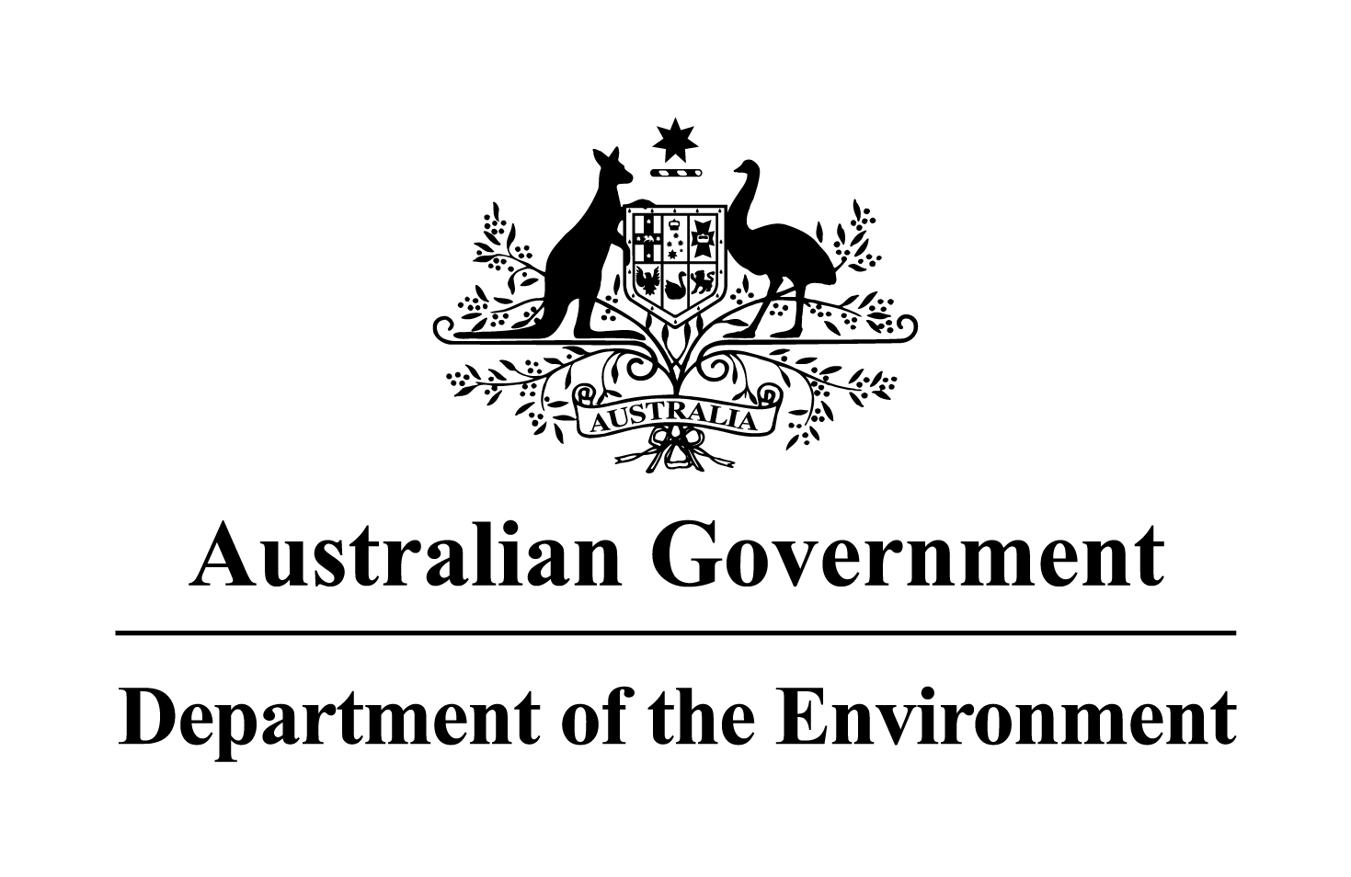

**NOTICE OF DECISION TO GRANT A PERMIT UNDER THE *HAZARDOUS WASTE (REGULATION OF EXPORTS AND IMPORTS) ACT 1989***

Pursuant to Section 33 of the *Hazardous Waste (Regulation of Exports and Imports) Act 1989*, notice is given that permit AUH15-063 was granted to Valen Pty Ltd (ACN 007 267 441), Level 1, 48 High Street, Northcote, Victoria, 3070 (Telephone + 61 3 357 8918).

The particulars of the permit are as follows:

1. the proposed exporter of the waste is Valen Pty Ltd at Level 1, 48 High Street, Northcote, Victoria, 3070 (Telephone + 61 3 357 8918);
2. the type of the waste is plugged steel, dissolved acetylene gas cylinders (porous mass within cylinder may contain asbestos) (Basel Code A2050);
3. the maximum quantity of the waste that may be imported is 600 tonnes;
4. the waste is to be strapped to pallets and packed in sealed shipping containers during whilst in transit;
5. the waste is to be transported by road to the port of export, shipped by sea, and then by road from the port of destination to the recovery facility;
6. the waste may only be imported during the permit period;
7. the waste is to be imported to the port of Sydney, Australia;
8. the waste is to undergo recovery operations at the facilities of Valen Pty Ltd;
9. the recovery operations are R4 – Recycling/reclamation of metals and metal compounds, R2 – Solvent reclamation/regeneration, and D1 – Deposit into or onto land, (e.g., landfill, etc.).

The permit period is from 1 February 2016 until the permit expiry date of 30 January 2017. All transboundary movements must be completed by the permit expiry date.

The permit includes and is subject to conditions.

Andrew McNee

Delegate of the Minister

Assistant Secretary

Chemicals and Waste Branch  
Department of the Environment

1 February 2016

______________________________________________________________________________

Subject to the *Administrative Appeals Tribunal Act 1975*, a person or persons whose interests are affected by this decision may, within 28 days, make an application in writing to the Department of the Environment requesting the reasons for the decision.

An application for independent review of the decision may be made to the Administrative Appeals Tribunal on payment of the relevant fee by the applicant within 28 days of receipt of the reasons for the decision, or within 28 days of this notice if the reasons for the decision are not sought. Applications should be made to the Deputy Registrar, Administrative Appeals Tribunal in your capital city,  
 see under Commonwealth Government Section in the White Pages. Further information or enquiries should be directed to:

Director, Hazardous Waste Section

Department of the Environment

GPO Box 787 CANBERRA ACT 2601

Telephone 1800 803 772, Facsimile (02) 6274 1164, or by E-mail at hwa@environment.gov.au.