 Government House

CANBERRA ACT 2600

#### 29 February 2016

## 

## ORDER OF AUSTRALIA

It is notified for general information that the Governor-General has:

Terminated the appointment as a Member of the Order of Australia in the General Division of

**Mr Warwick Arthur Watkins**

and

Cancelled the award of the Medal of the Order of Australia in the General Division made to

**Mr Desmond John Jarvis**

### By His Excellency’s Command

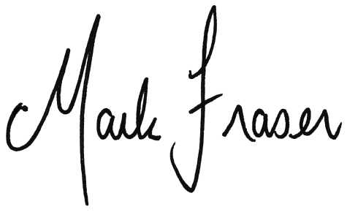

# Mark Fraser LVO OAM

#### Secretary of the Order of Australia