***Aboriginal and Torres Strait Islander Heritage Protection Act 1984* (Cth)**

**Notice of an application for the protection of North Lake and Bibra Lake known as Coolbellup and Walliabup in Perth, Western Australia**

**Invitation to make representations**

I, John Waters, hereby give notice as follows:

The Minister for the Environment, responsible for the *Aboriginal and Torres Strait Islander Heritage Protection Act 1984* (Cth)(the **Act**), has received an application made under section 10 of the Act seeking to protect an area that includes North Lake and Bibra Lake in Perth, Western Australia, and appointed me to provide a report to him under section 10(1)(c) of the Act.

### The applicants

The application is made by the South West Aboriginal Land & Sea Council on behalf of the Whadjuk Native Title Claimants.

### The purpose of the application

The application seeks the preservation or protection of the area specified in the application from injury or desecration. Section 10 of the Act enables the Minister to decide whether to make a declaration to preserve and protect the specified area, if the Minister is satisfied that the area is a significant Aboriginal area and is under threat of injury or desecration. In the Act, the term ‘significant Aboriginal area’ refers to an area that is of particular significance to Aboriginals in accordance with Aboriginal tradition. Section 3 of the Act provides definitions of ‘significant Aboriginal area’ and other relevant terms including ‘Aboriginal tradition’ and ‘injured or desecrated’. The area specified for protection, the claimed significance of the area, and the claimed nature of the threat of injury or desecration are summarised below.

### Matters the report is required to deal with

The Minister will consider my report under section 10 of the Act in relation to the area specified for protection before deciding whether to make a declaration under section 10 of the Act. Under section 10(4) of the Act, the report is required to deal with the following matters:

1. the particular significance of the area to Aboriginals;
2. the nature and extent of the threat of injury to, or desecration of, the area;
3. the extent of the area that should be protected;
4. the prohibitions and restrictions to be made with respect to the area;
5. the effects the making of a declaration may have on the proprietary or pecuniary interests of persons other than the Aboriginal or Aboriginals on whose behalf the application is made;
6. the duration of any declaration; and
7. the extent to which the area is or may be protected by or under a law of the State of Western Australia, and the effectiveness of any remedies available under any such law.

### The area sought to be protected (the 'specified area')

The applicants specify the area for which protection is sought as 'bounded by Progress Drive in the West, Bibra Drive in the South and East, and Farrington Road in the north '. The area is shown on the map below. The applicants refer to the area as the Coolbellup and Walliabup area.

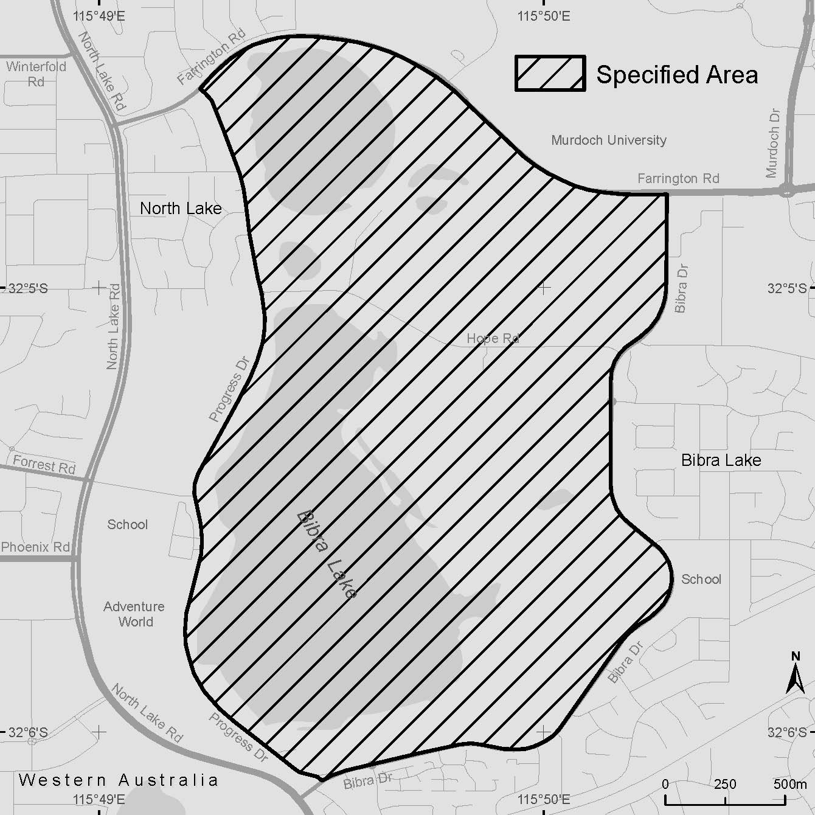

Figure 1 This map specifies the area for which protection is sought as bounded by Progress Drive in the West, Bibra Drive in the South and East, and Farrington Road in the north.

### Claimed nature of particular significance

The application indicates that the particular significance of the specified area arises because the area is:

* A registered mythological site under the *Aboriginal Heritage Act 1972* (WA).
* Part of a complex that includes six registered archaeological sites surrounding this mythological site, where the complex is greater than the sum of its parts.
* Of immense spiritual and cultural significance to the Whadjuk Noongars.
* Used by the Whadjuk Noongars for religious ceremonies.
* A Dreaming site.
* Home to wildlife with religious significance to the Whadjuk Noongars.
* Home to flora and fauna that are traditional food sources for the Whadjuk Noongars.
* Used for the cultural education of Noongar children.

### Claimed threat of injury or desecration

The application indicates that the threat of injury or desecration to the specified area arises from the planned extension of the Roe Highway through the middle of the area. The application indicates that the extension of the Roe Highway through this area would be inconsistent with Whadjuk Noongar tradition and would adversely affect the use of the area in accordance with the tradition as a site for ceremonial activity, camping, hunting, education and spiritual reflection.

### Invitation to make representations

Interested persons are invited to furnish representations in connection with my report to:

John Waters  
Solicitor  
6th Floor, Windeyer Chambers  
225 Macquarie Street

Sydney NSW 2000

Telephone: (02) 9235 3100

Email: [johnwaters@windeyerchambers.com.au](mailto:johnwaters@windeyerchambers.com.au)

Representations must be made in writing by close of business by 2 June 2016 or within such further period as may be allowed. **You should not send your representations directly to the Minister.** Representations will be provided to the Minister for Environment, and Department of the Environment, along with the section 10 report. Representations may be disclosed where it is authorised or required by law, to meet procedural fairness requirements, and in response to a request by a House or Committee of the Parliament of the Commonwealth.

If you wish to claim confidentiality over any part of your representation, please identify why you are claiming confidentiality and how you want confidentiality to apply. Even if your claim is accepted, any part of your representation could still be disclosed to other persons, such as in the circumstances set out above.