**AUSTRALIAN ELECTORAL COMMISSION**

*Aboriginal and Torres Strait Islander Act 2005*

Section 143G

*Torres Strait Regional Authority Election Rules 1996*

Rule 134A

**APPROVED FORMS FOR THE PURPOSES OF THE TORRES STRAIT REGIONAL AUTHORITY ELECTIONS**

I, TOM ROGERS, Australian Electoral Commissioner, referred to in section 18 of the *Commonwealth Electoral Act 1918* exercising of the power under Rule 134A of the *Torres Strait Regional Authority Election Rules 1996* (TSRA Election Rules), do hereby:

1. **APPROVE** the forms that appear in the Schedule to this instrument to be approved forms for the purposes of:
   1. Rule 7(1)(a) Nomination form;
   2. Rule 26(1)(a) Application for postal vote;
   3. Rule 30 Postal Voter Card;
   4. Rule 45 Pre-poll Voter Card; and
   5. Rule 64(1) Voter Card

of the TSRA Election Rules for the 2016 Torres Strait Regional Authority election.

1. **DECLARE** that this instrument takes effect upon execution.



Tom Rogers

Australian Electoral Commissioner

28 May 2016

Postal Vote Application **SCHEDULE**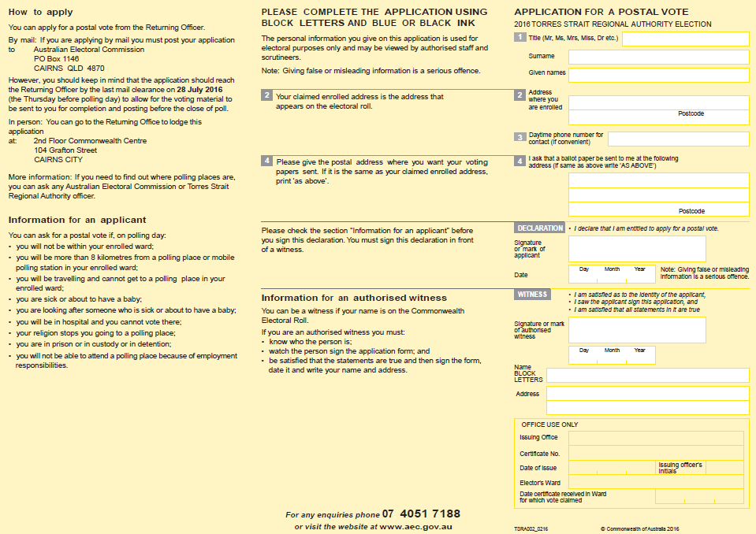

Nomination Form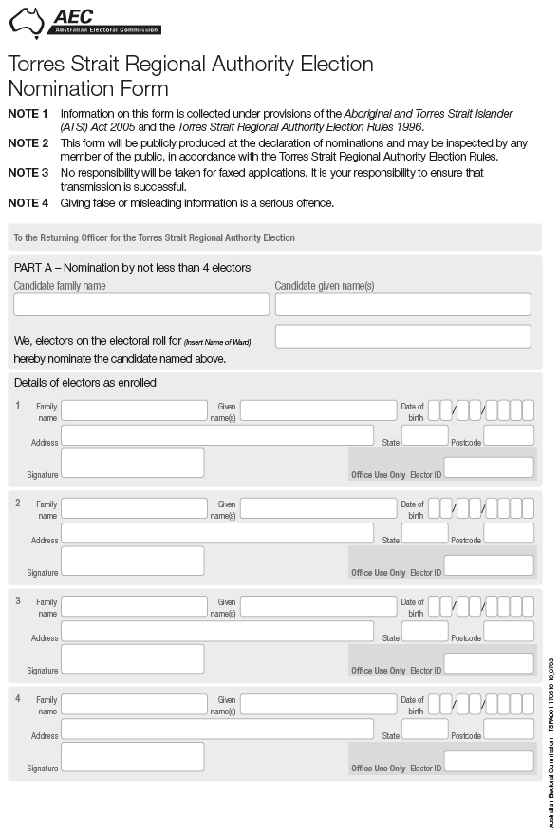

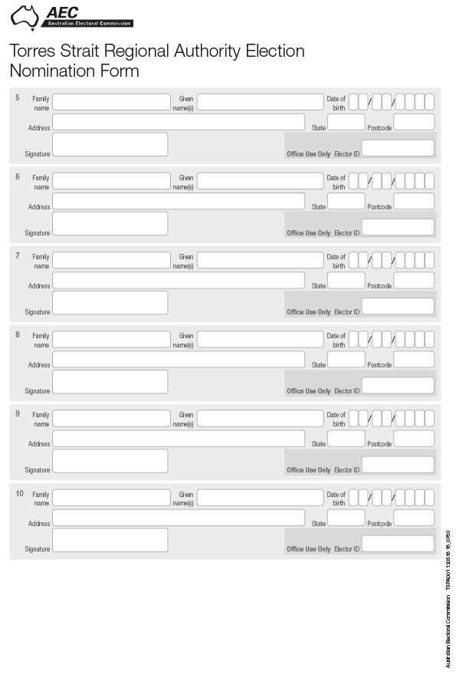

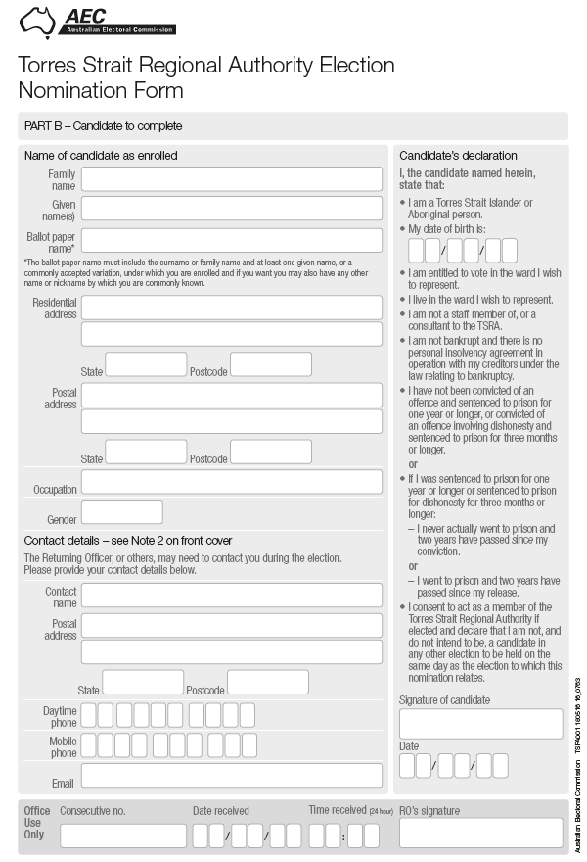

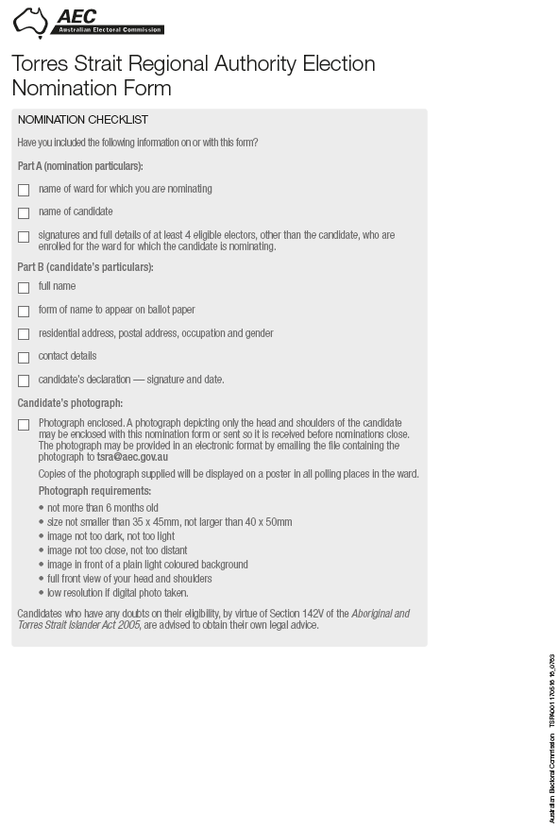

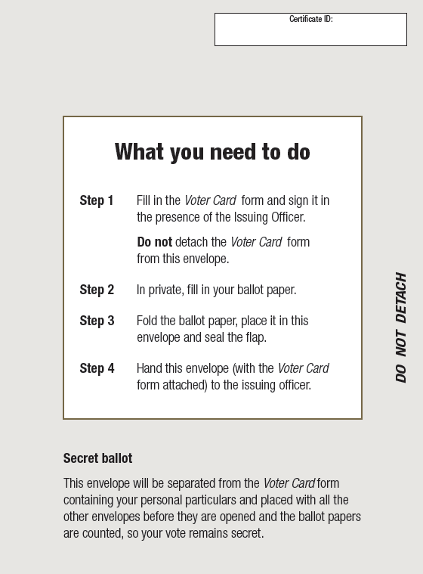Voter Card

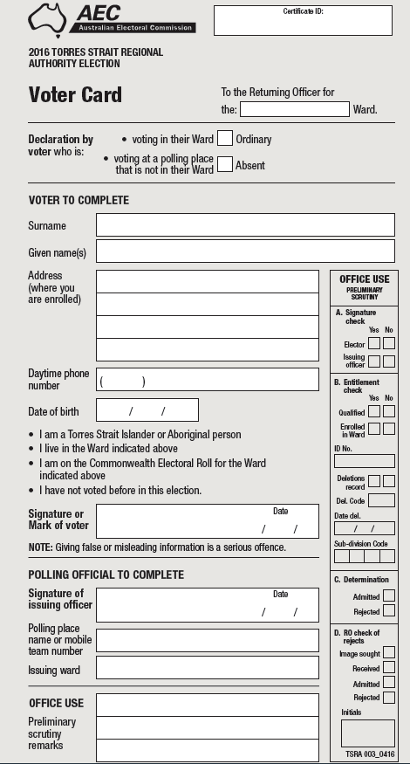

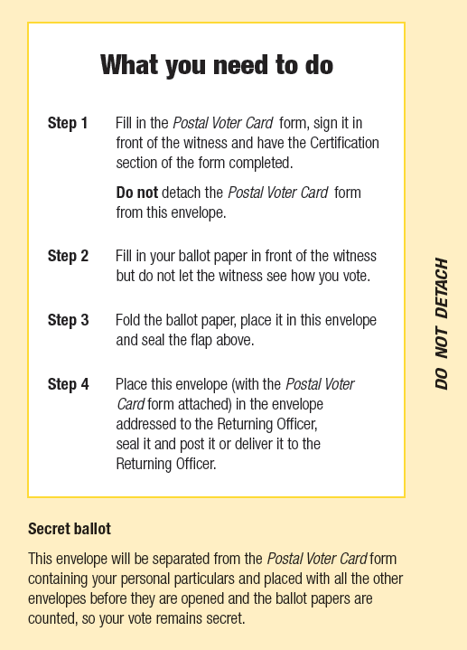Postal Voter Card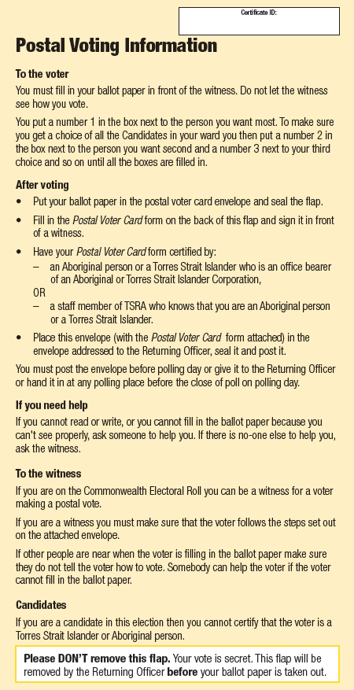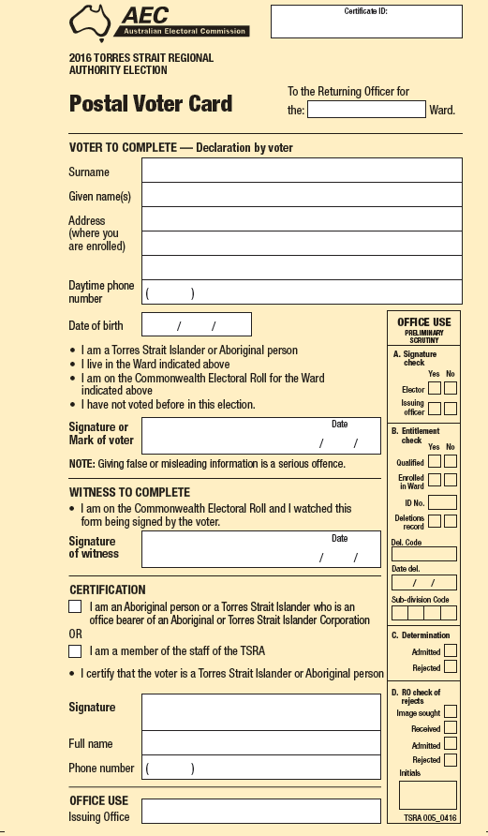

Pre-Poll Voter Card