Heavy Vehicle

Queensland Class 1 Comb Trailer Dimension Exemption Notice 2016 (No. 1)

Statutory Instrument Series:

Class 1/3 Heavy Vehicle Exemption Notice - Mass Exemption

- Purpose

The purpose of this notice is to exempt comb trailers from stated prescribed dimension requirements in Schedule 6 of the Heavy Vehicle (Mass, Dimension and Loading) National Regulation.
- Authorising Provision
This notice is made under section 117of the Heavy Vehicle National Law.
- Commencement
This notice commences on 1 July 2016.
- Expiry
This notice expires on 30 June 2017
- Title
This notice may be cited as the Queensland Class 1 Comb Trailer Dimension Exemption Notice 2016.
- Definitions

Unless otherwise stated, words and expressions used in this Notice have the same meanings as those defined in the HVNL.

In this Notice-

comb trailer means a trailer specifically designed and constructed for transporting the comb (the reaping implement) of a combine harvester and associated equipment.

combine harvester means a machine which simultaneously combines the operations of reaping, threshing and winnowing grain crops.
Form 14 Guideline means the Guideline for Excess Dimension Agricultural Vehicles and Agricultural Combinations; Vehicle and Drivers Form Number 14, Version 4, October 2013.
- Application

This Notice applies to eligible vehicles in Queensland.

This Notice applies to the movement of loaded and unloaded comb trailers.

- Dimension Exemption

A heavy vehicle operating under this Notice is exempted from the requirements included in Part 2 of Schedule 6 section 4 of the Heavy Vehicles (Mass, Dimension and Loading) National Regulation.
- Condition – Identification plate

A comb trailer must be fitted with an Identification Plate issued by the Commonwealth Department of Infrastructure and Regional Development.
- Operating Conditions

While operating under this notice, a comb trailer loaded with a header comb—
- must comply with the Form 14 Guideline as it applies to agricultural vehicles, as defined under the Form 14 Guideline, except as otherwise provided by this notice; and
- may only be used to carry—
    - the comb of a combine harvester; and
    - other items associated with the performance of the comb’s functions; and
    - and equipment used to repair agricultural vehicles;
and

must not, when being towed by an agricultural machine, exceed the comb trailer’s aggregate trailer mass and the tyre and axle manufacturer’s ratings; and

must not, when being towed by a motor vehicle, exceed any of the following—
- the towing vehicle’s towing capacity;
- the comb trailer’s aggregate trailer mass;
- the comb trailer’s tyre and axle manufacturer’s ratings or towing mass ratios;
and

must not exceed 80km per hour.

- Exclusion of prescribed conditions
The application of Schedule 8 of the National Regulation to this notice is expressly excluded.

- Conditions-General

It is a condition of this exemption that the driver of a heavy vehicle operating under this exemption must keep in the driver’s possession a copy of this Notice and must produce the Notice to an authorised officer when requested.

- Routes and Areas

A heavy vehicle operating under this Notice may operate on any route or in any area it would have been authorised to travel on under the Form 14 Guideline.

Date: 22 June 2016
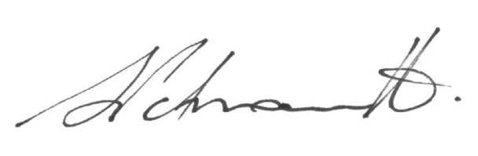

Sal Petroccitto
Chief Executive Officer
National Heavy Vehicle Regulator

