 Government House

CANBERRA ACT 2600

#### 31 August 2016

## 

## ORDER OF AUSTRALIA

It is notified for general information that the Governor-General has terminated the appointment as an Officer of the Order of Australia in the General Division of:

**Ms Bernadette Mary McMenamin**

### By His Excellency’s Command

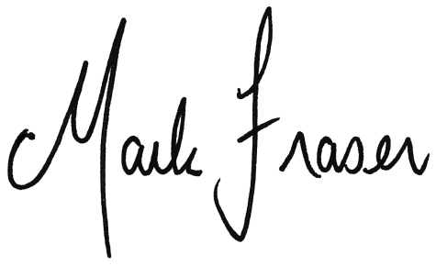

# Mark Fraser LVO OAM

#### Secretary of the Order of Australia