***Aboriginal and Torres Strait Islander Heritage Protection Act 1984* (Cth)**

**Notice of an application for the protection of a significant traditional area located within Billingurru (or Billingurr), Broome, Western Australia**

**Invitation to make representations**

I, Daniel Leo, hereby give notice as follows:

The Minister for the Environment and Energy, responsible for the *Aboriginal and Torres Strait Islander Heritage Protection Act 1984* (Cth)(**the Act**), has received an application made under section 10 of the Act seeking to protect a traditional area within Billingurru (or Billingurr), Broome, Western Australia, and appointed me to provide a report to him under section 10(1)(c) of the Act.

### The applicants

The application is made by the Yawuru Native Title Holders Aboriginal Corporation.

### The purpose of the application

The application seeks the preservation or protection of the area specified in the application, and further below, from injury or desecration. Section 10 of the Act enables the Minister to decide whether to make a declaration to preserve and protect the specified area, if the Minister is satisfied that the area is a significant Aboriginal area and is under threat of injury or desecration. In the Act, the term ‘significant Aboriginal area’ refers to an area that is of particular significance to Aboriginals in accordance with Aboriginal tradition. Section 3 of the Act provides definitions of ‘significant Aboriginal area’ and other relevant terms including ‘Aboriginal tradition’ and ‘injured or desecrated’. The area specified for protection, the claimed significance of the area, and the claimed nature of the threat of injury or desecration is set out below.

### Matters the report is required to deal with

The Minister will consider my report under section 10 of the Act in relation to the area specified for protection before deciding whether to make a declaration under section 10 of the Act. Under section 10(4) of the Act, the report is required to deal with the following matters:

1. the particular significance of the area to Aboriginals;
2. the nature and extent of the threat of injury to, or desecration of, the area;
3. the extent of the area that should be protected;
4. the prohibitions and restrictions to be made with respect to the area;
5. the effects the making of a declaration may have on the proprietary or pecuniary interests of persons other than the Aboriginal or Aboriginals on whose behalf the application is made;
6. the duration of any declaration; and
7. the extent to which the area is or may be protected by or under a law of the State of Western Australia, and the effectiveness of any remedies available under any such law.

### The area sought to be protected (the 'specified area')

The applicant specifies a traditional area located within Billingurru (Billingurr), Broome, Western Australia for which protection is sought. This includes:

* Registered Aboriginal Area #12839 (Reserve 50994).
* Parts of Lots 100, 985 and 13 Millington Road, Cable Beach above the 20 meter contour line.
* Parts of Lots 51, 50 and 3 Coucal Street, Cable Beach above the 20 meter contour line.

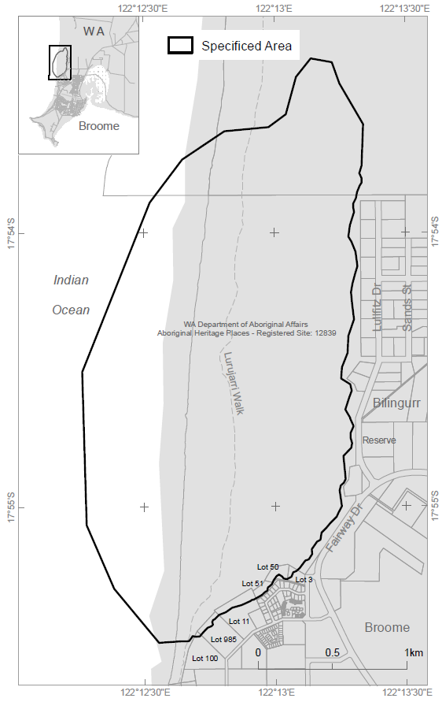

Figure 1 Map showing the specified area in Billingurru, Broome, Western Australia

### Claimed nature of particular significance

The application indicates that the particular significance of the specified area arises because:

* The area, comprised of a system of white sand dunes, is identified as a site connected to secret/sacred rituals and consists of a Law Ground, often referred to in English as “Hidden Valley”. The precise location of the law ground is known only to certain men who are initiated in the relevant Aboriginal traditions. The Law Ground is considered by the applicants to be a very powerful place of great significance.
* Gazing upon, looking towards and talking about the ceremonial area within the specified area is considered by the applicants as culturally inappropriate.
* Any damage to the white sand dunes is considered by the applicants as desecration of the specified area and contrary to Aboriginal law and custom.

### Claimed threat of injury or desecration

The application indicates that the potential injury or desecration is attributed to current development and construction and any future development and construction that will irreversibly desecrate or destroy the specified area.

### Invitation to make representations

Interested persons are invited to make representations on this matter:

Daniel Leo  
Director  
Leo Anthropological Services Pty Ltd as trustee for Cainbable Trust

PO Box 5120     
Moreland West     
VIC   3055

Telephone: 0487 266 622

Email: [**danleo@mail.com**](mailto:danleo@mail.com)

Representations must be made in writing by close of business by 2 November 2016 or within such further period as may be allowed. **You should not send your representations directly to the Minister.**

If you wish to claim confidentiality over any part of your representation, please identify why you are claiming confidentiality and how you want confidentiality to apply. Representations will be provided to the Minister for the Environment and Energy, and Department of the Environment and Energy, along with the section 10 report. Representations, even those subject to confidentiality, may be disclosed where it is authorised or required by law, to meet procedural fairness requirements, and in response to a request by a House or Committee of the Parliament of the Commonwealth.