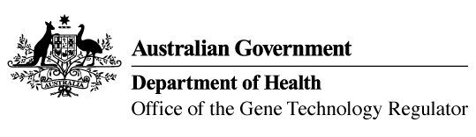
22 November 2016

Invitation to comment on a genetically modified (GM)
cotton field trial
Australia’s gene technology regulatory system is designed to protect the health and safety of people and the environment by identifying risks posed by, or as a result of, gene technology and managing those risks.
The Gene Technology Regulator is currently assessing licence application DIR 147 from Monsanto Australia Limited. The application is for a field trial (limited and controlled release) of cotton genetically modified for insect resistance and herbicide tolerance. The GMOs proposed for release are a GM cotton with a modified gene for protection against certain bugs, aphids and thrips; and combinations of this GM cotton with previously authorised insect resistant and/or herbicide tolerant cottons.
The purpose of the field trial is to assess the agronomic performance and pest resistance of the GM cottons under field conditions and to develop the GM cottons and produce seed for future releases, subject to further regulatory approvals.
The trial is proposed to take place in cotton growing areas of Australia from March 2017 to July 2021 in New South Wales, Queensland, Northern Territory, Victoria and Western Australia. The proposal is to plant up to 50 sites per year with a maximum combined area of 50 ha in 2017, 100 ha in 2018, and 250 ha per year in 2019 and 2020. The maximum planting size of individual trial sites is proposed to be 2 ha in 2017, 10 ha in 2018, and 50 ha per year in 2019 and 2020. The GM cotton would not be used in human food or animal feed.
A consultation Risk Assessment and Risk Management Plan (RARMP) has been prepared, which concludes that the proposed release would pose negligible risk to human health and safety or to the environment. A range of draft licence conditions would limit the size, location and duration of the release, as well as restrict the spread and persistence of the GMOs and the introduced genetic material.
The Regulator welcomes written submissions in order to finalise the RARMP, which will then inform the decision on whether or not to issue the licence. The consultation RARMP and related documents can be obtained from the OGTR website under What’s New or by contacting the Office. Please quote application DIR 147 in any correspondence.
Submissions should be received by close of business on 4 January 2017.
Office of the Gene Technology Regulator, MDP 54, GPO BOX 9848 CANBERRA ACT 2601
Telephone: 1800 181 030 Facsimile: 02 6271 4202 E-mail: ogtr@health.gov.au
OGTR website www.ogtr.gov.au

