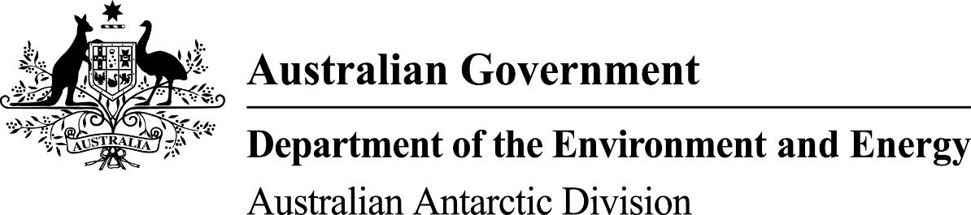

Antarctic Treaty (Environment Protection)
(Environmental Impact Assessment) Regulations 1993

Notice of completion of an Initial Environmental Evaluation

I, Gillian Louise Slocum, Delegate of the Minister for the Environment and Energy, give notice pursuant to Regulation 7 of the Antarctic Treaty (Environment Protection) (Environmental Impact Assessment) Regulations 1993 that I have determined pursuant to 12H and 12J of the Antarctic Treaty (Environment Protection) Act 1980 that the geotechnical site investigations and environmental baseline sampling that the Antarctic Modernisation Taskforce has proposed to undertake in the Vestfold Hills in the Australian Antarctic Territory is likely to have a minor or transitory impact on the environment, and I have authorised the Antarctic Modernisation Taskforce to carry on the activity.

To obtain a copy of the Initial Environmental Evaluation, please contact:

Barbara Frankel
Antarctic Modernisation Taskforce
Australian Antarctic Division
203 Channel Highway
Kingston
TAS 7050

Gillian Slocum
Delegate of the Minister for the Environment and Energy
24 November 2016

